

COMMUNITY PROFILE REPORT

© 2011 Austin Affiliate of Susan G Komen for the Cure

COMMUNITY PRO

 2011

Disclaimer:

The information in this Community Profile Report is based on the work of Austin Affiliate of Susan G. Komen for the Cure® in conjunction with key community partners.  The findings of the report are based on a needs assessment public health model but are not necessarily scientific and are provided "as is" for general information only and without warranties of any kind. Susan G. Komen for the Cure ® and its Affiliates do not recommend, endorse or make any warranties or representations of any kind with regard to the accuracy, completeness, timeliness, quality, efficacy or non-infringement of any of the programs, projects, materials, products or other information included or the companies or organizations referred to in the report.

**Acknowledgements**

The Austin Affiliate would like to thank the following people for their help, direction and efforts with this document.

Authors/Community Profile Team:

Christy Casey-Moore, Executive Director

Monica Saavedra, Director of Mission Services

Harriett Choffel, Director of Grants

Karen Killoren, Volunteer

Natasha Smith, Graphic Design Intern

Expert Partners:

Thank you to the following Key Informants and Focus Group Coordinators, for assuring that the voice of our community is heard:

Deirdre Anderson

Babette Bennett

Andria Brannon

Laura Carvalho

Laurie Casias

Rhoda Chavira

Dr. Jeffrey Chin

Tammie Danielson

Gina Faubion

Carol Gaskamp

Jessica Jones

Karen Killoren

Dawn Parsons

Dr. Debra Patt

Lydia Perez

Candice Swain

Anne Wade

Breast Cancer Resource Center

* Jessica Jones
* Marjorie Gallece

Texas State Cancer Advocacy Movement for Colleges and Outreach (CAMCO)

* Gloria Martinez

Community Action Incorporated

* Lydia Perez
* Keri Worthy

El Buen Samaritano

* Vicky Lara

Community Health Centers of South Central Texas

* Sarah Zamora
* Anne Wade

A special thank you to the amazing women who participated in one of the many focus groups held throughout the five county service area; they are the reason we fight for this cause every day.

Table of Contents

Executive Summary 5

Introduction 5

Statistics and Demographic Review: 6

Health Systems Analysis 6

Qualitative Data Overview 7

Key Findings and Themes 8

Conclusions and Affiliate Priorities 8

Introduction 10

Affiliate History 10

Organizational Structure 10

Description of Service Area 10

Purpose of the Report 11

Breast Cancer Impact in Affiliate Service Area 12

Methodology 12

Overview of Affiliate Service Area 12

Communities of Interest 16

Conclusions 18

Health Systems Analysis of Target Communities 19

Overview of Continuum of Care 19

Methodology 19

Overview of Community Assets 19

Public Policy 26

Key Informant Interview Findings 27

Conclusions 27

Breast Cancer Perspectives in the Target Communities 29

Methodology 29

Review of Qualitative Findings 30

Conclusions 32

What We Learned, What We Will Do 34

Review of the Findings 34

Conclusions 34

Action Plan 34

# Executive Summary

## Introduction

The Susan G. Komen for the Cure, Austin Affiliate ® was established in late 1999 to spread the life-saving message of early detection and to support breast cancer screening and education programs in Central Texas. The Austin Affiliate covers five counties including Bastrop, Caldwell, Hays, Travis, and Williamson, as shown in Figure 1. These five counties make up an area of 4,284 square miles and encompass a population of slightly more than 1.67 million residents.

*Figure 1. Service area County Map*

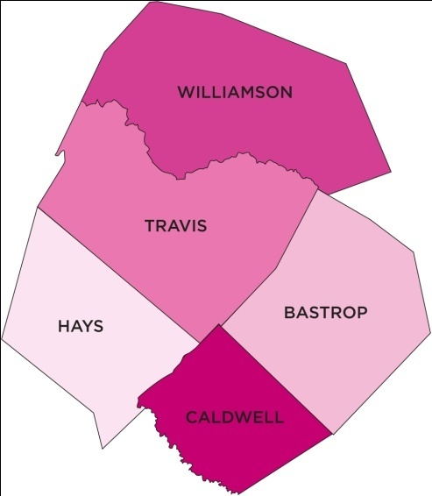

The Race for the Cure, held in November, is the signature fund raising event of the Affiliate. It has grown to an attendance of approximately 21,000 participants, recorded during the 2010 Race. The Affiliate has granted out over 10 million in the twelveyearsof its existence to help women in the service area, and in 2011 we will grant out over $1.1 million alone. The services funded include screening, diagnostic services, treatment, patient navigation services, breast health education and outreach, emergency funds needed for everyday expenses and support services for women undergoing breast cancer treatment.

Every two years each of the Susan G. Komen for the Cure ® affiliates conducts a Community Profile to gather and organize information for the purpose of creating a snapshot of the state of breast health and breast health services in the Affiliate service area. This report is intended to serve as a roadmap to the services currently funded and to identify any existing gaps in those services for the five county service area. It is also intended to outline program plans on how the Affiliate will seek to meet the needs of the identified groups which will potentially lead to change in behavior in an effort to reduce breast cancer mortality. A plan was outlined by the Executive Director, the Director of Mission Services and the Director of Grants to determine community participation in the Community Profile.

## 

## Statistics and Demographic Review:

In examining demographic and breast cancer data and statistics in the Affiliate’s five county service area, a number of sources were researched and utilized. The sources used for the Profile, include but were not limited to, Texas Cancer Registry, Thomson Reuters ©2010, NCI, and Cancer Control P.L.A.N.E.T. In the process of researching and obtaining breast health statistics, both the Texas Cancer Registry and the Behavioral Risk Factor Surveillance System (BRFSS) provided vital information for the profile.

After careful review of both national and local breast health statistics, the following emerged: the disproportionate incidence and/or mortality rate in African American and Hispanic women, the exponential growth in the Hispanic population, and the high poverty rates, and lack of breast health services in Bastrop and Caldwell counties. The American Cancer Society shows that the higher mortality rate in African-American women (35.1 vs. 22.5 in non Hispanic Whites) in Texas may be related to differences in access to and utilization of early detection and treatment and differences in tumor characteristics.

Additionally, American Cancer Society U.S. data shows that even though Hispanic women have lower breast cancer rates (90.2 per 100,000) they are more likely to die from the disease (17.2 per 100,000). This contradiction is due to the fact that Hispanic/Latina women are less likely to participate in mammography screening and more likely to be diagnosed at later stages of breast cancer.

Therefore, we will focus our outreach efforts on both the African American and Hispanic populations, to inform them about their increased risk, the importance of breast cancer early detection, and to motivate them to get screened. Additionally, a continued emphasis will be kept on both Bastrop and Caldwell Counties since the data continues to demonstrate they have the highest poverty rates and least amount of breast health service providers in their counties.

## Health Systems Analysis

The health systems analysis of the community profile included interviews with individuals in each of the five counties in the service area representing medical professionals, oncologists, breast cancer survivors, indigent care clinics and current Affiliate grantees. A complete list of breast health service providers spanning the continuum of care were documented in tables by County. These providers were contacted by phone to verify the service offerings or were provided as a known resource by key informants during the interview process.

The outreach and breast health education component to all women in the rural counties can be strengthened as verified by the number of women who are fearful, lack information, and do not seek preventive health services. Gaps in diagnostic and treatment services continue in Bastrop and Caldwell Counties. Barriers to care remain consistent over time: lack of insurance; fear of costs, outcomes, family reactions; lack of transportation or high cost of gasoline; time off work for medical appointments and treatment; loss of income during treatment; financial obligations during diagnosis and treatment; numerous and costly co-payments for insured women.

Medical services have increased significantly in Hays, Travis and Williamson Counties. Large hospital networks are expanding into Bastrop and Williamson Counties during the next two years. While there are medical services, not all facilities offer a complete continuum of care. Thus, patient navigators play critical support roles in helping clients negotiate the overwhelming healthcare systems and linking clients to necessary resource supports.

Komen grantees have strong collaborative networks and provide a critical safety- net throughout the five county service area for clients who reach their doors. Challenges remain in increasing awareness about grantee services and securing grantees to address gaps in transportation, psycho-social support, emergency financial support, targeted breast health education and outreach. Financial support for treatment is critical and must remain a focus for the Affiliate.

The Affiliate has a strong screening mammography program and has increased partnerships with medical centers, hospitals, and radiology associations to ensure that screening sites remain available at no cost to our target population throughout all counties. These partnerships will continue in 2011-2012. We will support Seton Family of Hospitals in their quest to obtain funding for new digital mobile mammography equipment.

The Affiliate will continue to maintain a visible presence with the legislature to support funding for the state health department’s Breast and Cervical Cancer Screening (BCCS) program and Cancer Prevention and Research Institute of Texas (C.P.R.I.T.).

## Qualitative Data Overview

The qualitative component of the community profile included a total of seven focus groups and five community leader/breast cancer survivor interviews with women from varying ethnicities and locations within the service area. The participants represented the wide diversity in our five county service area including breast cancer survivors, uninsured and/or underinsured women, women who had little or no connection to breast cancer, and women who had accessed the services provided by the Affiliate grantees.

As anticipated, the focus groups demonstrated that the breast cancer survivors in the groups had a higher level of knowledge around the issues of breast health, particularly around the topics of breast health, resources, and access to care and treatment. However many of the survivors stated that the prior to diagnosis, this was not the case, and many described their breast health knowledge as limited. In comparison, the participants, who were not breast cancer survivors have limited knowledge regarding breast cancer and breast cancer screening, but almost no knowledge about breast cancer resources in the community. Their breast health knowledge gave us great insight into the myths and barriers that still exist in the Affiliate service area. Additionally, many of the women were not aware of the services provided by the Susan G Komen for the Cure grantees; much of their knowledge was limited to the annual race event.

The community leader/breast cancer interviews provided information related to the needs of the breast cancer survivor community which highlighted the need for psycho-social support, and the lack of treatment options for the uninsured.

After data collection, both the focus group and the key informant interview responses were analyzed to identify emerging theme. Response data was then compared to data sources provided by Komen Headquarters and other sources. These include but were not limited to C.A.N.C.E.R Control Planet, The Texas Cancer Registry, Thomson-Reuters © 2010, The Behavioral Risk Factor Surveillance Center of the CDC and the National Cancer Institute.

## Key Findings and Themes

Focus groups, questionnaires, and key informant interviews with current Affiliate grantees, health care providers, breast cancer survivors, and community leaders, revealed a number of key findings with regards to breast health in the five county service areas. Three dominant themes emerges from the focus groups and key informants as to why women do not get screened: fear related to breast health issues; lack of education about breast health and breast health services; cultural beliefs. However, many women expressed the importance of communicating breast health care to different populations, not just those over 40, in order to help subside some of these fears. Many women felt strongly about the importance of communicating the availability of services for the uninsured and underinsured, whether it be through education events in their counties, mass marketing via radio, or distributing resource sheets in various doctors’ offices, stores, pharmacies, and even social media sites for the younger demographic. Currently, they do not feel they have adequate access to breast health information, and only a few women knew where to access it. Some of the sources they mentioned included: their doctors, friends, church, the Susan G. Komen for the Cure ® website, American Cancer Society, Lance Armstrong Foundation, or miscellaneous internet sites.

In addition to fear, other barriers to screening include: lack of knowledge about screening, cost of screening, not knowing where to go for free or low cost screening, transportation, embarrassment, “it won’t happen to me”, cultural barriers related to privacy of body, low priority, and language barriers.

When providers and key informants were asked the question related to why they believe women don’t get screened, many of the responses were similar to those from the focus group participants. This can only lead us to believe that both providers and community leaders understand the barriers to screening, and therefore we must find a way to bridge the gap between the community and the providers so that women can have access to these life saving exams.

## Conclusions and Affiliate Priorities

Based on the findings of the Community Profile from data gathered from interviews and research, the Affiliate developed priorities which align with their strategic plan. The Strategic Plan will be used to improve and guide the grant process and education programs for the Affiliate in the next two years. These priorities include:

1. Increase the breast health education and outreach to uninsured and underinsured Hispanic women across all 5 counties,
2. Engage volunteers in the African American community to provide breast health education and serve in an advisory role to the Affiliate with issues related to the African American population and breast health,
3. Establish a speakers bureau comprised of community members, providers, and key leaders that will allow us to increase the number of educational events and speaking engagements in the 5 county service area,
4. And collaborate with community and health care leaders to explore lowering the cost of breast health services in Bastrop and Caldwell Counties.

A full copy of the 2011 Community Profile, can be found on our website at [www.komenaustin.org](http://www.google.com/url?q=http%3A%2F%2Fwww.komenaustin.org&sa=D&sntz=1&usg=AFQjCNGEyVJxSGf4M8A9bFAmhtriMCJpqw) or contact Monica Saavedra, Director of Mission Services at 512.684.3884 for more information.

# Introduction

## Affiliate History

The Affiliate was established in 1999 to spread the life-saving message of early detection and to support breast cancer screening, education, and treatment programs in Central Texas.  The first Race for the Cure ® was held in Austin in November of 1997, and the Affiliate has granted over $10M since 1999 to fund these programs.

## Organizational Structure

The Affiliate has both a Board of Directors and a full time and part time staff of employees working daily to advance the mission of Susan G. Komen for the Cure ®. There are a total of 11 members on the Board of Directors, which include a President, Vice President, Treasurer, and 8 at large member positions, and a total of eight staff; 5 full-time staff, and 3 part time staff. These positions include: Executive Director, Director of Mission Services, Marketing and Communications Manager, Operations Manager, Grants Director, Program Coordinator, Web Administrator, and Book Keeper. In addition to the board and staff, the affiliate takes pride in their cadre of approximately 2,500 volunteers who participate each year in a number of activities including the operations and coordination of the Race for the Cure; the marquis fundraising event, assistance to the affiliate in day to day office functions, community outreach, etc. Finally, volunteers participate in a number of committees including the Grants Review Committee.

## Description of Service Area

The Austin Affiliate’s service area encompasses Bastrop, Caldwell, Hays, Travis and Williamson Counties. Including rural, suburban and urban areas, these counties each provide unique challenges and opportunities in breast health care.

*Figure 2. Service Area County Map*

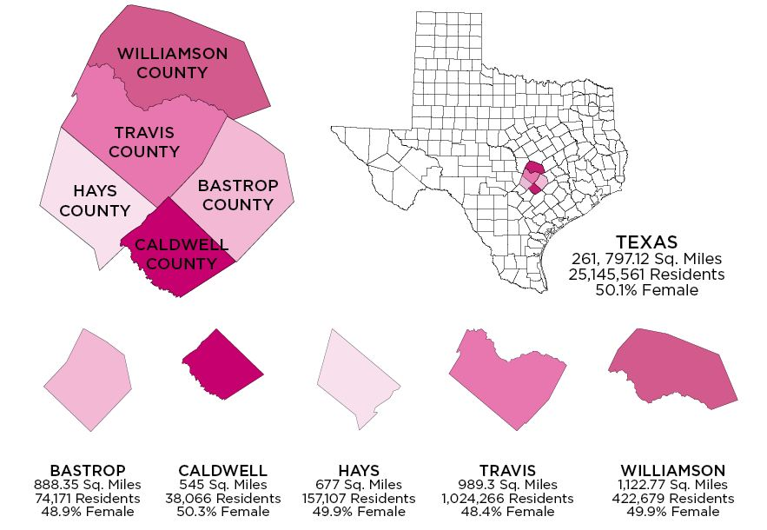

[Williamson](http://www.google.com/url?q=http%3A%2F%2Fwww.countymapsoftexas.com%2Fwilliamson.shtml&sa=D&sntz=1&usg=AFQjCNFNtMrgf9Ol1k6aVqkqpUl6HBQCCQ) - Cedar Park, Florence, Georgetown, Granger, Hutto, Jarrell, Leander, Round Rock, Taylor, Thrall

[Travis](http://www.google.com/url?q=http%3A%2F%2Fwww.countymapsoftexas.com%2Ftravis.shtml&sa=D&sntz=1&usg=AFQjCNGY9wTuMTSaWUCUxst8lZ7AfYEPsQ) - Austin, Del Valle, Garfield, Jollyville, Jonestown, Lago Vista, Lakeway, Manchaca, Manor, Pflugerville, Rollingwood, West Lake Hills

[Hays](http://www.google.com/url?q=http%3A%2F%2Fwww.countymapsoftexas.com%2Fhays.shtml&sa=D&sntz=1&usg=AFQjCNFziotGYSkujS_Uw_vUFflXD_TvvA) - Buda, Driftwood, Dripping Springs, Kyle, San Marcos, Wimberley

[Caldwell](http://www.google.com/url?q=http%3A%2F%2Fwww.countymapsoftexas.com%2Fcaldwell.shtml&sa=D&sntz=1&usg=AFQjCNEFgEaSOj5XP26frPgdw1Zrr7AvBg) - Dale, Lockhart, Luling, Martindale, Niederwald, Uhland, Maxwell

[Bastrop](http://www.google.com/url?q=http%3A%2F%2Fwww.countymapsoftexas.com%2Fbastrop.shtml&sa=D&sntz=1&usg=AFQjCNH0jMsubyKN93wS0fm0YxcewMxl9g) - Bastrop, Cedar Creek, Elgin, Paige, Smithville

## Purpose of the Report

This report is intended to serve as a roadmap to the services currently funded, assist us with the identification of gaps in breast health services for the five county service area, and highlight communities that need special attention. These three items combined will determine the Action Steps included in the report and how the Affiliate will seek to meet the needs of the identified groups in order to effect behavior change over the next two years. This will help us achieve the affiliate’s mission of increasing access to breast health services and therefore impact breast cancer mortality.

# Breast Cancer Impact in Affiliate Service Area

## Methodology

In examining demographic and breast cancer data and statistics in the Austin Affiliate’s five county service area, a number of sources were researched and utilized. The sources used for the Profile, include but were not limited to, Texas Cancer Registry, Thomson Reuters © 2010, NCI, and Cancer Control P.L.A.N.E.T. and the Behavioral Risk Factor Surveillance System (BRFSS) Data was also gleaned from the County Information Project, an initiative of the Texas Association of Counties which provided further data on each county’s demographics and geography. The methodology for data collected included face-to-face and/or telephone interviews with 14 key informants, e-mail questionnaires with the 2010/2011 slate of grantees; and a total of seven focus groups consisting of women from the service area who represented the wide diversity of community members that are served by the affiliate including: breast cancer survivors, African American women, non- English speaking Hispanic women, women from rural areas, and women who had received services from the Affiliate grantee pool. The women in these focus groups were from various age brackets and varied socio-economic status; they all shared the commonality of being uninsured.

## Overview of Affiliate Service Area

According to data from the Texas Cancer Registry it is estimated that in 2011, 1,007 women will be diagnosed with breast cancer and 6 men, while it is expected that 172 mortalities from women will occur and 1 from men. Table 1 reflects the 2011 estimates for new cases and expected deaths for the 5 County service area.

*Table 1. Cases and Deaths 2011*

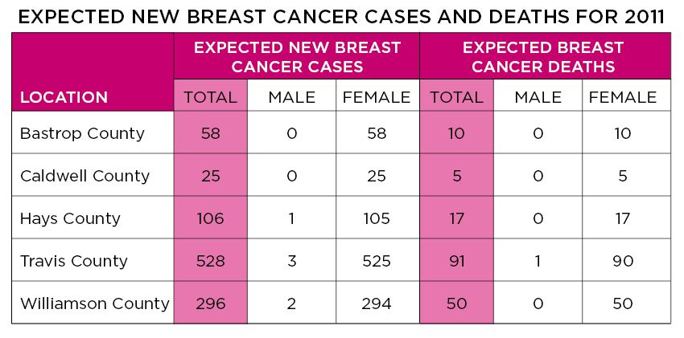

© 2010 Texas Cancer Registry

Figure 3 below shows the incidence rates by County. As you can see, Hays, Travis and Williamson Counties have the highest rates. This can be attributed to the access to screening providers in those areas.

*Figure 3 Female Breast Cancer Incidence Rates*

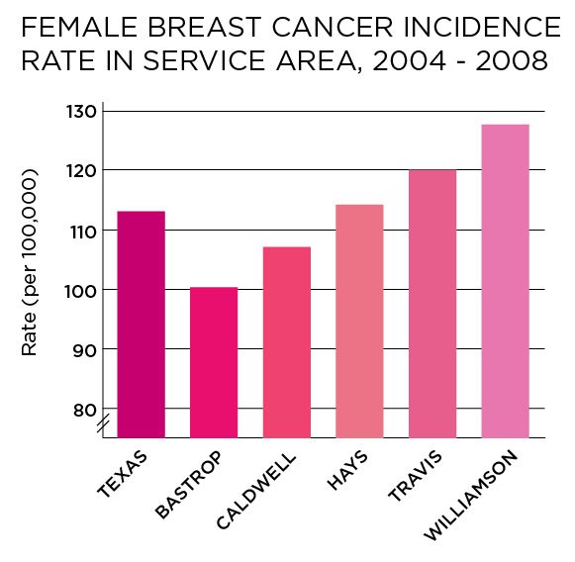

Figure 4 below breaks down the incidence rates by Race and Ethnicity in each of the 5 Counties. The data shows the Non Hispanic white women continue to have the highest incidence of breast cancer, which is in line with the state and National rates. Table 1 showed that Williamson County has the highest incidence rate, followed by Travis and Caldwell.

*Figure 4. Incidence Rate by Ethnicity in the 5 County Service Area*

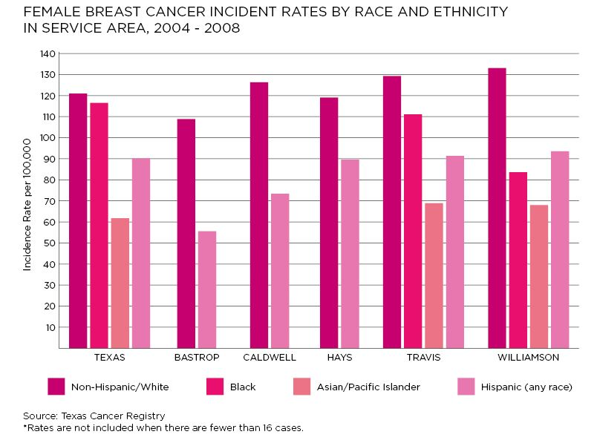

© 2010 Texas Cancer Registry

Figure 5 below provides a more in-depth look at the incidence rate by race and stage of diagnosis. This data in this figure shows that more African American women are diagnosed at later stages than White women and other ethnicities; Figure 5 will show how this impacts the mortality rate in African American women.

*Figure 5. Incidence Rate by Stage and Ethnicity in the 5 County service area (based on 2009 Female Population)*

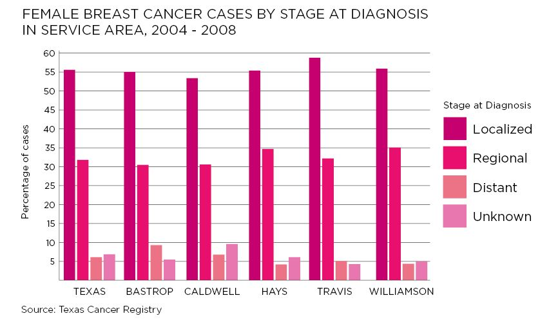

©2010 Texas Cancer Registry

Figure 6 provides us with a pictorial representation of the breast cancer mortality rates for each County.

*Figure 6: Female Breast cancer Mortality Rates*

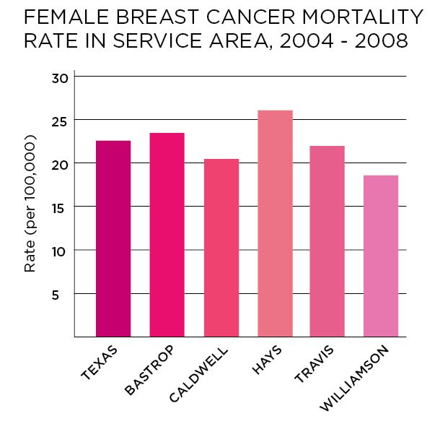

The data in Figure 6 demonstrates that Bastrop and Hays counties have mortality rates above the State average. Figure 7 below provides a breakdown of mortality rates by race/ethnicity in each County.

*Figure 7: Female Breast Cancer Rates by Race and Ethnicity*

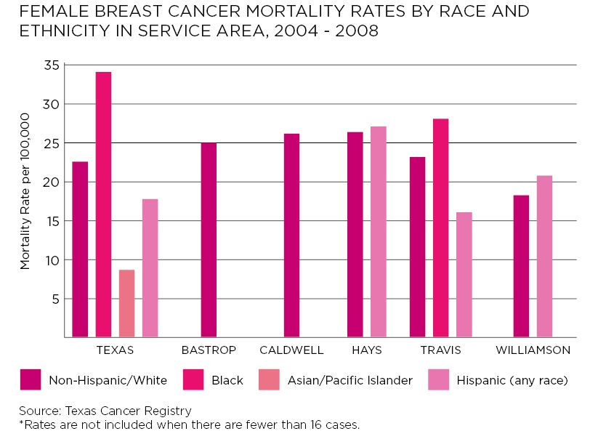

For those counties with more than 36 cases per race/ethnicity you can see that minorities, particularly African American women and Hispanic women continue to have the highest rates of breast cancer mortality. This is reflective of the data shown in Figure 4 above that show that African American women are diagnosed at a later stage with breast cancer. (We do not have diagnosis by stage data for Hispanic women at this time, but qualitative date supports this finding which shows that Hispanic women trend similarly due to lack of access of to screening, and cultural barriers which delay access to care and early detection.

Figure 8 shows the total number of women over the age of 40 in the 5 County service area who have not gotten a mammogram in the past year, and some of the reasons for not having one are included.

Figure 8: Women 40+ Without a Mammogram

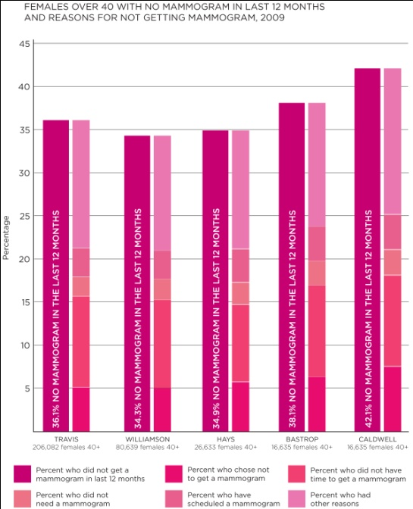

Thomson Reuters © 2010

As you can see from Figure 8, there is a high rate of non-adherent women to mammography screening across all counties, including Travis County which actually has the highest number of breast health services. (See Health Systems Analysis Section for services provided by County.) According to the table above, the most common reason for not getting screened was “Didn’t have time”, which validates the findings from the focus groups conducted, which included time as one of the barriers to breast cancer screening. Other commonly cited barriers included: cost, embarrassment, and fear, which we can safely assume based on our date fall under the “Other Reasons” category listed in Table 2.

## Communities of Interest

The Austin Affiliate’s service area encompasses Bastrop, Caldwell, Hays, Travis and Williamson. Including rural, suburban and urban areas, these counties each provide unique challenges and opportunities in breast health care. Just over 49 percent of the service area’s 1.6 million residents are women, and over half a million of these women are 40 years and older, the targeted age for breast cancer screening. The figure below highlights the 3 prominent populations in the 5 county service area.

*Figure 9. Ethnicity by County (based on 2009 Total Population)*

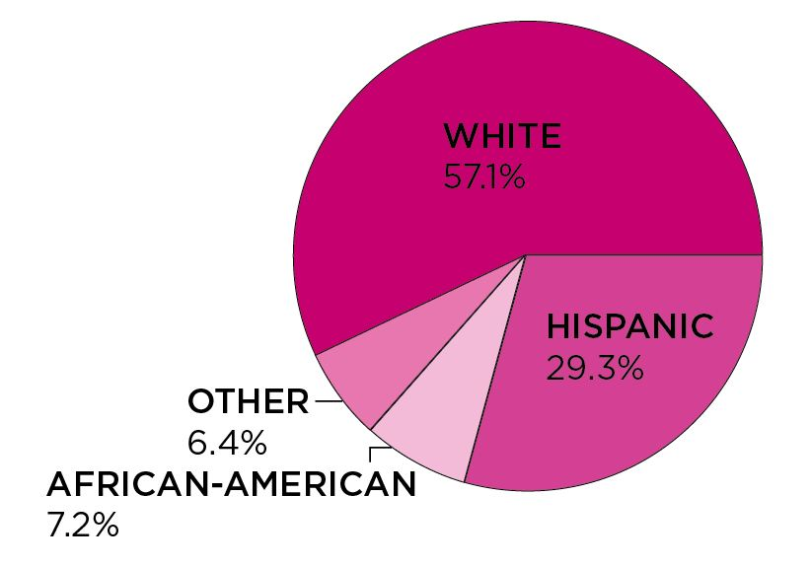

Thomson Reuters © 2010

For the entire service area, whites make up the majority (57.1 percent) followed by Hispanics (29.3 percent) and African Americans (7.2 percent). There are unfortunate health disparities which continue to exist among those of certain populations, and recognition of the presence of these populations allows for culturally sensitive approaches to be taken in outreach efforts. Table 3 shows a more in-depth breakdown of the population by County, focusing on females.

*Figure 10: 2009 Female Population by Ethnicity*

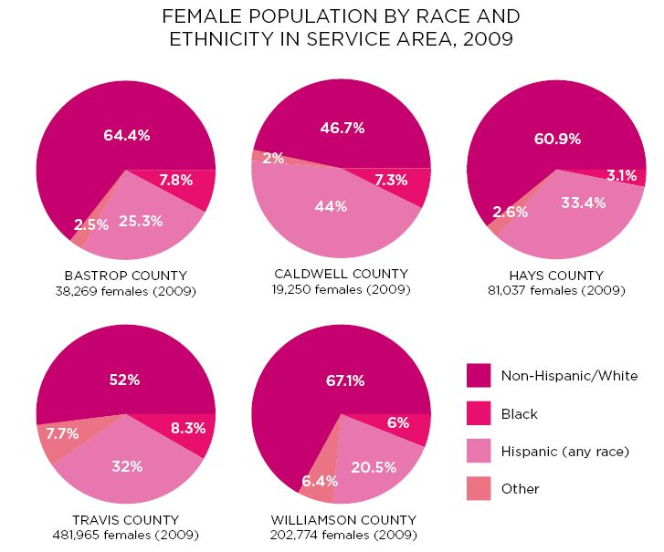

Thomson Reuters © 2010

The following figure contains data on two of the key demographic variables that impact the five county service area; they include health insurance and poverty level. These two key elements are primary determinants as to whether or not a woman will obtain breast cancer screening since cost is one of primary barriers to breast cancer screening.

*Figure 11. Poverty Level and Uninsured Females by County*

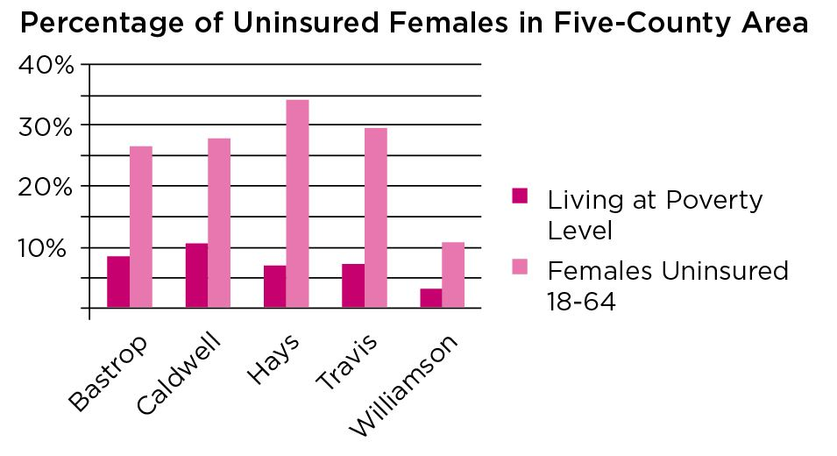

Thomson Reuters © 2010

Direct correlations between economic status and the overall health of populations have been repeatedly proven throughout innumerable studies. It is therefore imperative to understand the socioeconomic background of residents being targeted for education and outreach. Within the Affiliate’s five county service area, there is a notable variance of economic statuses present per county, ranging from only 3.4 percent of the population living at the poverty level in Williamson County to a much larger 10.7 percent in Caldwell County.

Awareness of the number of uninsured residents is also an important piece of information in understanding the state of overall health of a particular geographic region. According to the Kaiser State Health Facts, twenty-six percent (26 percent) of Texans are uninsured, which is nine percentage points higher than the national average (17 percent), and continues to rank as the #1 state in the Country with the most uninsured residents. In the Affiliate service area, it is interesting to note that Williamson County, which has the lowest poverty rate, also has the lowest uninsured rate.

The Affiliate service area is greatly influenced in some counties by the number of Universities and the education of their faculty. It has long been documented that the health of a county is proportionate to education levels of this county, however since the Affiliate service area is unique in that it contains a large number of universities and colleges including a large number of uninsured students, we will not be able make this link.

## Conclusions

It is evident that the Affiliate service area continues to grow, and with this growth, there is an expected increase for breast health services. A significant growth has taken place in the Hispanic population. It is the fastest growing population in the 5 county service area, and has the highest number of uninsured. While great gains have been made by the Austin Affiliate grantees in reaching this population, data from the 2009 Behavioral Risk Factor Surveillance System of the CDC shows that Hispanic women are still lagging other ethnic groups in screening mammograms. Data also shows that breast cancer is the most commonly diagnosed cancer among Hispanic women, and is the leading cause of cancer death among Hispanic women. The breast cancer incidence rate in Hispanic women is 27 percent lower than that in non-Hispanic white women. Hispanic women are also 20% more likely to die from breast cancer than non-Hispanic white women diagnosed at a similar age and stage. This is a direct result of lack of access to care and treatment.

Even though the percentage of African Americans in our service area is small compared to other races and ethnicities, disparities continue to exist with African American women. This group of women continues to suffer from higher breast cancer incidence and mortality. Breast cancer is the number one cause of cancer in African American women and the second cause of cancer death. The five year relative survival rate for breast cancer diagnosed in 1996-2004 among African American women was 77 percent, compared to 90 percent among whites. This difference can be attributed to both later stage at detection and poorer stage-specific survival among African American women. Only about half (51%) of breast cancers diagnosed among African American women are diagnosed at a local stage, compared to 62 percent among white women. Studies have documented unequal receipt of prompt, high-quality treatment for African American women compared to white women. There is also evidence that aggressive tumor characteristics are more common in African American women that white women.

As the population grows in the service area due to availability of jobs, home affordability, and educational opportunities, the affiliate must adapt to not only the increase in demand but to meeting the needs for each individual group. The additional growth is expected to bring in and/or expand the number of races and ethnicities in the service area. This growth will require further study of their culture, customs, myths and beliefs in order to provide culturally appropriate services that will be encourage all women to seek and acquire their breast health needs.

# Health Systems Analysis of Target Communities

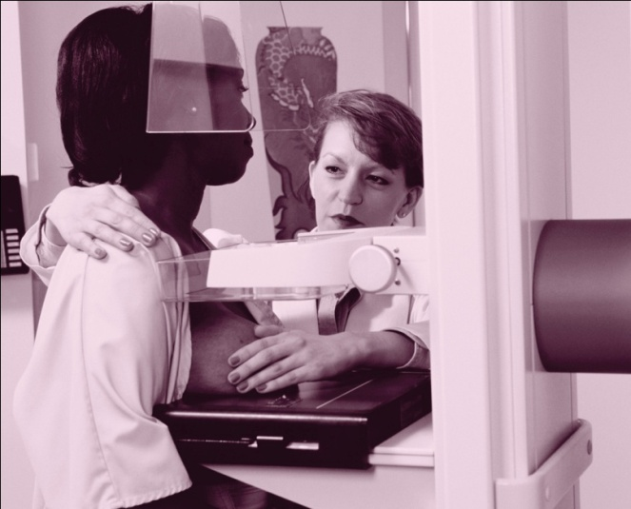

## Overview of Continuum of Care

The continuum of care for breast cancer in our complex system includes the provision of education and outreach, and, access to screening, diagnosis, treatment and support. Coordination of care throughout each step of the continuum is critical to successful navigation of the unique medical systems. Women may access the system at various phases of the continuum depending on their need. They may enter, exit, and re-enter the continuum as medical situations evolve. Therefore, the service needs may fluctuate and continual analysis of these services is necessary in order to provide optimal support to our target population.

## Methodology

Contact was made with each of the Affiliate’s 2010 grantees as well as with approximately 16 service providers in clinics, medical centers, oncology offices, radiology centers, foundations, health departments, and non-profit organizations across all five counties in order to gain a better understanding of the services available to women in the service area for a total of approximately 26 interviews. Most interviews were conducted over the phone lasting from 20-50 minutes, with the exception of two which were submitted via email.

Individual county charts were created to delineate providers by county and type of service offered along the continuum of care accordingly: education/outreach, screening, coordination of care, diagnosis, treatment, support, and advocacy. These charts allow the Affiliate to see types of services available in each county and to more clearly analyze gaps.

## Overview of Community Assets

Medical services have increased throughout the Affiliate service area during the past two years. All counties in the service area have hospitals or major hospital networks and medical clinics that provide services to underinsured and uninsured individuals. Not all of these facilities have a complete continuum of care so individuals can become confused about the availability of services and type of care available. Affiliate grantees are closely linked to service providers in the five counties and have a strong collaborative network among them. See Figure 12 for continuum of care model.

*Figure 12. Continuum of Care Model*

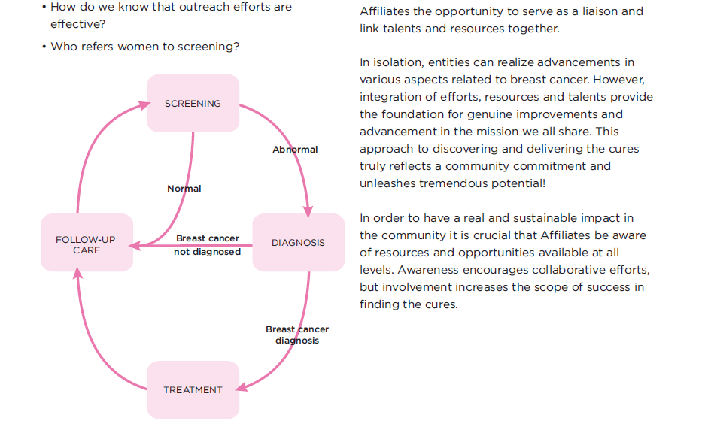

A variety of providers offer screening mammography services in all five counties. While there are numerous locations with on-site mammography services, there are also options for mobile mammography services to come into communities.

Travis and Caldwell Counties each have two BCCS providers whereas Bastrop, Hays, and Williamson Counties are served by one BCCS provider. The BCCS program provides state money to agencies for free screening, case management, and medical treatment. Some BCCS providers are more expeditious in their enrollment process than others.

The most noticeable gaps along the continuum occur in Caldwell County where Breast and Cervical Cancer Early Detection Screening providers and grantees are available to arrange for funding but treatment options are not available in county. Some diagnostic and treatment options are available in Bastrop County but often clients prefer to go to Travis or Hays Counties for treatment. There are still medical providers who are unaware of Komen funded services for our targeted population.

The principal challenge facing the Austin Affiliate is the increased demand for services. As the population in the five county service area grows, so do the needs for outreach and education, screening, treatment, and support services. Other factors that affect quality outcomes for clients include the need for emergency financial services, psycho-social support, and transportation. Finally, the exponential growth of the Hispanic population raises the demand for Hispanic specific marketing and awareness approaches, including culturally competent and bilingual providers and support services that understand the needs of the Hispanic population.

The majority of the breast health programs available in the Affiliate service area are in the more geographically metropolitan areas. An analysis of providers has been completed and tables have been developed to document the services in each County to be included in an affiliate resource manual. An example of a table of one of our communities of interest is below; services provided are outlined on top, and providers for that specific service are entered under each column.

Continuum of Care in Bastrop County (* Denotes receipt of SGK Grant for this service)

|  |  |  |  |  |  |  |
| --- | --- | --- | --- | --- | --- | --- |
| **EDUCATION** | **SCREENING** | **COORDINATION OF CARE** | **DIAGNOSIS** | **TREATMENT** | **SUPPORT** | **ADVOCACY** |
| American Cancer Society |  |  |  |  | American Cancer Society | American Cancer Society |
| Lance Armstrong Foundation |  | Lance Armstrong Foundation |  |  | Lance Armstrong Foundation | Lance Armstrong Foundation |
|  |  |  | Lost Pines Center for Cancer Care-Bastrop | Lost Pines Center for Cancer Care-Bastrop | Lost Pines Center for Cancer Care-Bastrop |  |
| Indigent Health Care-Bastrop | Indigent Health Care-Bastrop |  |  |  |  |  |
|  | Riverbend Diagnostics-Bastrop (Seton) |  |  |  |  |  |
|  | Seton Family of Hospitals* |  |  |  |  |  |
|  |  | Texas Oncology-Smithville | Texas Oncology-Smithville | Texas Oncology-Smithville | Texas Oncology-Smithville |  |
|  | Smithville Regional Hospital(Seton) |  | Smithville Regional Hospital (Seton) |  | Smithville Regional Hospital (Seton) |  |
| Community Action, Inc.* | Community Action, Inc.* | Community Action, Inc.* | Community Action, Inc.* | Community Action, Inc.(BCCS) | Community Action, Inc.* |  |
| The Breast Cancer Resource Centers of Texas |  | The Breast Cancer Resource Centers of Texas |  |  | The Breast Cancer Resource Centers of Texas | The Breast Cancer Resource Centers of Texas |
|  |  |  |  |  | Helping the Aging, Needy, & Disabled* |  |
|  |  |  |  | WINGS* | WINGS* |  |
| Susan G. Komen for the Cure-Austin Affiliate |  |  |  |  | Susan G. Komen for the Cure-Austin Affiliate | Susan G. Komen for the Cure-Austin Affiliate |

Continuum of Care in Caldwell County (* Denotes receipt of SGK Grant for this service)

|  |  |  |  |  |  |  |
| --- | --- | --- | --- | --- | --- | --- |
| **EDUCATION** | **SCREENING** | **COORDINATION OF CARE** | **DIAGNOSIS** | **TREATMENT** | **SUPPORT** | **ADVOCACY** |
| American Cancer Society |  |  |  |  | American Cancer Society | American Cancer Society |
| Lance Armstrong Foundation |  | Lance Armstrong Foundation |  |  | Lance Armstrong Foundation | Lance Armstrong Foundation |
| Indigent Health Care | Indigent Health Care |  |  |  |  |  |
| Community Centers of South Central Texas | Community Centers of South Central Texas | Community Centers of South Central Texas(BCCS) | Community Centers of South Central Texas(BCCS) | Community Centers of South Central Texas(BCCS) | Community Centers of South Central Texas |  |
| Seton Family of Hospitals* | Seton Family of Hospitals* | Seton Family of Hospitals* | Seton Family of Hospitals* |  |  |  |
| Community Action, Inc.* | Community Action, Inc.* | Community Action, Inc.* | Community Action, Inc.* | Community Action, Inc.(BCCS) | Community Action, Inc.* |  |
|  |  |  |  | WINGS* | WINGS* |  |
| Susan G. Komen for the Cure-Austin Affiliate |  |  |  |  | Susan G. Komen for the Cure-Austin Affiliate | Susan G. Komen for the Cure-Austin Affiliate |

Continuum of Care in Hays County (* Denotes receipt of SGK Grant for this service)

|  |  |  |  |  |  |  |
| --- | --- | --- | --- | --- | --- | --- |
| **EDUCATION** | **SCREENING** | **COORDINATION OF CARE** | **DIAGNOSIS** | **TREATMENT** | **SUPPORT** | **ADVOCACY** |
| American Cancer Society |  |  |  |  | American Cancer Society | American Cancer Society |
| Lance Armstrong Foundation |  | Lance Armstrong Foundation |  |  | Lance Armstrong Foundation | Lance Armstrong Foundation |
| Central Texas Medical Center | Central Texas Medical Center | Central Texas Medical Center | Central Texas Medical Center |  | Central Texas Medical Center |  |
|  |  | Wonder World Center for Cancer Care | Wonder World Center for Cancer Care | Wonder World Center for Cancer Care | Wonder World Center for Cancer Care |  |
|  | Austin Radiological Association |  | Austin Radiological Association |  |  |  |
|  |  | Texas Oncology | Texas Oncology | Texas Oncology | Texas Oncology |  |
| CommuniCare Health Centers* | CommuniCare Health Centers* | CommuniCare Health Centers* | CommuniCare Health Centers* |  |  |  |
| National Center for Farmworker Health* |  | National Center for Farmworker Health* |  |  |  |  |
| Community Action, Inc.* | Community Action, Inc.* | Community Action, Inc.* | Community Action, Inc.* | Community Action, Inc.(BCCS) | Community Action, Inc.* |  |
| Seton Family of Hospitals* | Seton Family of Hospitals* | Seton Family of Hospitals* | Seton Family of Hospitals* | Seton Family of Hospitals | Seton Family of Hospitals* |  |
| Planned Parenthood* | Planned Parenthood* |  |  |  |  | Planned Parenthood |
| The Breast Cancer Resource Centers of Texas* |  | The Breast Cancer Resource Centers of Texas* |  |  | The Breast Cancer Resource Centers of Texas* | The Breast Cancer Resource Centers of Texas |
|  |  |  |  |  | Helping the Aging, Needy, & Disabled* |  |
|  |  |  |  | WINGS* | WINGS* |  |
| SGK for the Cure-Austin Affiliate |  |  |  |  | SGK for the Cure-Austin Affiliate | SGK for the Cure-Austin Affiliate |

Continuum of Care in Travis County (* Denotes receipt of SGK Grant for this service)

|  |  |  |  |  |  |  |
| --- | --- | --- | --- | --- | --- | --- |
| **EDUCATION** | **SCREENING** | **COORDINATION OF CARE** | **DIAGNOSIS** | **TREATMENT** | **SUPPORT** | **ADVOCACY** |
| American Cancer Society |  |  |  |  | American Cancer Society |  |
| Lance Armstrong Foundation |  | Lance Armstrong Foundation |  |  | Lance Armstrong Foundation | Lance Armstrong Foundation |
| CommunityCARE (FQHS)-Family Wellness Center* | CommunityCARE (FQHS)-Family Wellness Center* |  | CommunityCARE-Family Wellness Center* | CommunityCARE-Family Wellness Center (BCCS) |  |  |
| Peoples Community Clinic | Peoples Community Clinic |  |  |  |  |  |
|  | Austin Radiological Association |  | Austin Radiological Association |  |  |  |
|  |  | Texas Oncology | Texas Oncology | Texas Oncology | Texas Oncology |  |
|  |  |  |  |  | ALLGO |  |
|  |  |  |  |  | Cancer Connection |  |
|  |  |  |  |  | Care Communities |  |
|  |  |  |  |  | Capital of Texas Team Survivors |  |
| Seton Family of Hospitals* | Seton Family of Hospitals* | Seton Family of Hospitals* | Seton Family of Hospitals* | Seton Family of Hospitals | Seton Family of Hospitals* |  |
| St.David’s Healthcare Network | St.David’s Healthcare Network | St.David’s Healthcare Network | St.David’s Healthcare Network | St.David’s Healthcare Network | St.David’s Healthcare Network |  |
| Samaritan Health Ministries* | Samaritan Health Ministries* |  | Samaritan Health Ministries* |  | Samaritan Health Ministries |  |
| El Buen Samaritano Episcopal Mission* |  | El Buen Samaritano Episcopal Mission* | El Buen Samaritano Episcopal Mission* |  |  |  |
| Planned Parenthood* | Planned Parenthood* |  |  |  |  | Planned Parenthood |
| The Breast Cancer Resource Centers of Texas* |  | The Breast Cancer Resource Centers of Texas* |  |  | The Breast Cancer Resource Centers of Texas* | The Breast Cancer Resource Centers of Texas |
|  |  |  |  |  | Helping the Aging, Needy, & Disabled* |  |
|  |  |  |  |  | Sisters Network |  |
|  |  |  |  | WINGS* |  |  |
| S G K for the Cure-Austin Affiliate |  |  |  |  | S G K for the Cure-Austin Affiliate | SGK for the Cure-Austin Affiliate |

Continuum of Care in Williamson County (* Denotes receipt of SGK Grant for this service)

|  |  |  |  |  |  |  |
| --- | --- | --- | --- | --- | --- | --- |
| **EDUCATION** | **SCREENING** | **COORDINATION OF CARE** | **DIAGNOSIS** | **TREATMENT** | **SUPPORT** | **ADVOCACY** |
| American Cancer Society |  |  |  |  | American Cancer Society | American Cancer Society |
| Lance Armstrong Foundation |  | Lance Armstrong Foundation |  |  | Lance Armstrong Foundation | Lance Armstrong Foundation |
| Lone Star Circle of Care | Lone Star Circle of Care |  |  |  |  |  |
| Wilco Care County Indigent Health Care Program | Wilco Care County Indigent Health Care Program |  |  |  |  |  |
|  | Austin Radiological Association |  | Austin Radiological Association |  |  |  |
|  |  | Texas Oncology | Texas Oncology | Texas Oncology | Texas Oncology |  |
| Scott & White HealthCare | Scott & White HealthCare | Scott & White HealthCare | Scott & White HealthCare | Scott & White HealthCare | Scott & White HealthCare |  |
| St. David’s Healthcare Network | St. David’s Healthcare Network | St. David’s Healthcare Network | St. David’s Healthcare Network | St. David’s Healthcare Network | St. David’s Healthcare Network |  |
| Community Action, Inc.* | Community Action, Inc.* | Community Action, Inc.* | Community Action, Inc.* | Community Action, Inc.(BCCS) | Community Action, Inc.* |  |
| Seton Family of Hospitals* | Seton Family of Hospitals* | Seton Family of Hospitals* | Seton Family of Hospitals* | Seton Family of Hospitals | Seton Family of Hospitals* |  |
| Samaritan Health Ministries* | Samaritan Health Ministries* |  | Samaritan Health Ministries* |  | Samaritan Health Ministries |  |
| El Buen Samaritano Episcopal Mission |  | El Buen Samaritano Episcopal Mission | El Buen Samaritano Episcopal Mission |  |  |  |
| Planned Parenthood* | Planned Parenthood* |  |  |  |  | Planned Parenthood |
| The Breast Cancer Resource Centers of Texas* |  | The Breast Cancer Resource Centers of Texas* |  |  | The Breast Cancer Resource Centers of Texas* | The Breast Cancer Resource Centers of Texas |
|  |  |  |  |  | Helping the Aging, Needy, & Disabled* |  |
|  |  |  |  |  | Sisters Network |  |
|  |  |  |  | WINGS* | WINGS* |  |
| Susan G. Komen for the Cure-Austin Affiliate |  |  |  |  | Susan G. Komen for the Cure-Austin Affiliate | Susan G. Komen for the Cure-Austin Affiliate |

## Public Policy

The public policy efforts at the Affiliate have led to great outcomes for the Affiliate and for all Texans. 2010 was an election year, and new faces have the entered the political landscape, therefore we will make an effort to get to know these new elected officials and introduce the Susan G. Komen for the Cure Affiliate priorities and message. The Affiliate covers two of the three counties (Hays and Caldwell) in District 45 represented by new comer Representative Jason Isaac. While Representative Rose, an immense advocate for Susan G. Komen for the Cure ® and breast health services is no longer in office, Senator Nelson, a co-author of the bill that created the Center for Prevention and Research Institute of Texas, continues to be a tremendous supporter and advocate. Additionally we continue to a strong relationship with Representative Doggett, who continues be one of the Affiliate’s biggest supporters, and was the honorary chair at the first annual Austin Race for the Cure.

The Affiliate has a close working relationship with Representatives Donna Howard, Dawnna Dukes, Elliott Naishtat, Eddie Rodriquez, and Mark Strama. We will continue to work with this group of elected officials as the need arises. We have also worked closely with Senators Kirk Watson and Jeff Wentworth. Representative Naishtat serves as Vice-Chair of the Public Health committee and is a member of the Human Services Committee. Representative Dukes is the Vice-Chair of the Appropriations committee.

We will continue to work with Representative Kleinschmidt from Bastrop County as we secure goals for 2011. Continued efforts will be made to work with the elected officials in Bastrop County to work towards a relationship that extends into the county government as well as the elected officials of each major rural town in Bastrop County. This would hopefully open up the dialogue of how resources are being utilized for the women of this county and where Affiliate dollars could be spent more effectively.

The efforts of the Affiliate on the state level continue to be an important one for the women of Central Texas. It is clear that efforts by the Austin Affiliate have an impact on what happens at the state level and those efforts will be continued as budgets are tightened. Our participation in visits with both local and state representative have increased this year, due to looming state and national budget deficits. Therefore, the Affiliate participated in Texas Komen Lobby Day, Cancer Awareness Lobby Day, and National Komen Advocacy Day; all in April ‘11. These visits served to increase our visibility with new congressmen, strengthen current partnerships, and educate them about breast cancer priorities. A plan between the Executive Director and the Director of Mission Services is currently being outlined to assure continued support through year round monthly visits with state and national legislators.

The Affiliate also maintains active representation in the Cancer Alliance of Texas (CAT), Texas State Cancer Advocacy Movement for Colleges and Outreach (CAMCO), the Breast Health Collaborative of Texas, and the Cancer Prevention and Research Institute of Texas (CPRIT), to strengthen partnerships, maintain awareness of statewide issues and resources, and increase visibility throughout the state.

## Key Informant Interview Findings

A woman’s experience in moving through the continuum of care varies not only according to insurance status, Breast and Cervical Cancer Early Detection Program status, and residency status, but also by county of residence and cultural background. Generalizations are not easy to make about the experiences given the array of variables. While there are services available, a frequent comment is that women in rural communities lack trust or confidence in services from smaller community hospitals and medical facilities regardless of economic status or cultural background. It is clear that many women, regardless of economic status or cultural background, place higher priorities on things besides health and often think screening mammograms are not important. Some of the providers stated that many of these women do not want to know if they have a medical problem because they cannot afford treatment. Other women expressed concern about exposure to radiation and the debate about the recommendations to have a mammogram every two years instead of annually. What is evident is that women need a medical home where they can return to a familiar and trusted provider.

Furthermore, the key informants stated that women who have supportive assistance from patient navigators or case managers to help them negotiate the available resources and services have more positive experiences and tend to complete needed medical diagnostics and treatment. Women who qualify for Medicaid for Breast and Cervical Cancer (MBCC) generally have patient navigator support throughout their treatment, and women who do not qualify are referred for assistance to an organization that focuses on serving these women. These women also continue to receive navigation support. There is concern that MBCC clients may not be as equally informed and receive the same array of information about treatment options as insured women. However, having health insurance does not mean a cost factor does not exist; the cost of co-payment assistance for insured women can be overwhelming due to the myriad of medical appointments required during the diagnostic process. Once women enter treatment, the issues of transportation, childcare and financial obligations at home become problematic.

Door-to-door breast health education programs have been very effective in one rural county. Intentional and successful collaboration between grantees in this county provide a safety- net for the targeted population and maximize the number of women served. However, some providers expressed concern that not all providers or clients are aware of grantee and/or Affiliate support services. One grantee reported that awareness of services was increased exponentially by conducting breast health specific marketing throughout the county. A local organization found success in raising awareness by bringing different generations together and encouraging males to get involved.

## Conclusions

Increasing awareness about Susan G. Komen for the Cure ® and Affiliate resource services for providers and potential clients remains critical to improving access to breast health services throughout the service area. The key is to make individuals aware of the existence of services within our target communities, provide encouragement and education about the importance of breast health screening, and help navigate the women through the barriers.

While the number of medical services and facilities have increased, not all facilities offer a complete continuum of care. Gaps in diagnostic and treatment services continue in Bastrop and Caldwell Counties. Increasing the options for patient navigator support is necessary to help clients negotiate the overwhelming healthcare systems and link clients to necessary resource supports.

Barriers to care remain consistent over time encompassing insurance availability, a variety of fear factors, transportation issues, loss of income during diagnostics and treatment, costly co-payments for insured women, and costs of treatment.

Collaborative networking among Affiliate grantees remains a strength and necessity to ensure a safety- net for clients and increased access to education and diagnostic and treatment support.

Increased visibility by the Affiliate in the rural counties will be important to maximize resources and support systems.

# Breast Cancer Perspectives in the Target Communities



## Methodology

Three different data collection methods were utilized to gather community data. They included: one on one interviews with breast cancer survivors, survey questionnaires with current affiliate grantees, and focus groups with women from the community.

Four breast cancer survivors participated in one on one phone interviews in order to share their experiences regarding their breast cancer diagnosis, express their needs or concerns about the breast health services they received, and provide recommendations on how Komen can better deliver information to women in need. These women were selected through a variety of methods including grantee referral, callers to the Affiliate office, Affiliate volunteers, and previous grantee service users. In addition to survivor interviews, affiliate grantees responded to email questionnaires about the breast health services they provide, breast health trends they have observed in their community, and women’s concerns about breast health. Questionnaires were emailed to all 12 of the 2009-2010 grantees, a total of 7 responded via email; the remainder responded to questions during a phone call.

Finally, a total of seven focus groups, at least one in each of the counties served by the affiliate, were held to gather breast health information from women in the community. This information was related to breast health knowledge, breast health services, health education preferences, and recommendations for improving access to breast health in their community. Assistance with focus group coordination was provided by three of the Affiliate grantees whom assisted in recruitment of the participants and securing a location. A “focus group coordinator” was assigned for each of the grantees that assisted with the focus groups procedure. Their responsibilities included: recruiting women from their service area, who were 20 years of age or older, and had an interest in sharing their thoughts on breast health. Focus group coordinators recruited their participants by posting flyers in their health centers, offices, local churches, local convenience stores, and through local support groups.

Each of the focus groups consisted of 6-14 participants and were approximately one and half hours in length. The groups were a true reflection of the women who reside in five County service area, and included a mix of: Hispanic women, African American women, white women, breast cancer survivors, co-survivors, monolingual Spanish speakers, English speakers, and uninsured or underinsured women. Five of the focus groups took place in grantee offices and/or health centers with the exception of two groups, one of which took place in at church in Luling-Caldwell County and the other at the Affiliate office. All locations were chosen based on proximity and ease for the participants. Upon initiation of the focus groups, an introduction that included a thorough explanation of the purpose for the groups were given to each of the women about the process and the purpose for the focus groups. After the introductions were made, the participants were provided with consent forms to sign, and the groups began shortly thereafter. The women represented in the focus groups were from diverse backgrounds, ethnicities and Social Economic Status, including two Spanish speaking groups. Each of the focus groups followed the same outline of questions and was facilitated by the Director of Mission Services in order to allow for consistency in the collection of desired information. Five focus groups were conducted in English, and 2 of the focus groups were conducted in Spanish. At the conclusion of each of the focus groups, participants were provided with a $10 HEB gift card for the participation. Notes and audio recordings captured the information gathered during the focus groups.

Upon completion of the data collection, the transcripts were reviewed to identify emerging themes that impact the Affiliate. Below is a review of the most pertinent findings.

## Review of Qualitative Findings

A number of relevant themes and key findings were noted with the collection of information from grantee interviews, focus groups and survey responses. The following themes get to the root of breast cancer incidence and mortality; they are in response to the question asked of all groups including: women, grantees, and providers. The question was: “What are some reasons women (like you) do not get a mammogram or clinical breast exam?”

Cost/No health insurance:

Cost was the most cited response to this question. Most of the women acknowledged the importance of the exams, but said they could not afford to get one. This barrier was brought up in all but one focus group. Other women were afraid that if they were diagnosed with breast cancer, it would be too expensive, so they would rather not know. The providers also stated that “cost” was the most common barrier cited by the women they serve.

Fear:

Fear was the second most common barrier mentioned. However fear was related to several things: fear of the exam-(pain, and radiation), fear of being diagnosed with cancer, and fear of death from cancer. In fact one woman said “ignorance is bliss”. This was a common theme, and like cost, it was an issue common across all groups, regardless of race or ethnicity.

Body issues:

Embarrassment/Modesty/Religion: these all relate to the reluctance to show their body to someone else. Some women stated that they were not raised to talk about or allow someone else to view their body. An exam such as a mammogram or clinical breast exam therefore was not something they would get.

Misc:

Transportation, lack of priority, limited English proficiency, and ignorance were also brought up as reasons for why women don’t get breast health exams. The absence of public transportation in Bastrop, Caldwell, Hays and Williamson Counties creates a challenge for women needing to travel to screenings and cancer treatment, particularly in Bastrop and Caldwell where there are no in-county options for treatment. Lack of priority, ignorance, and limited English proficiency can be addressed through education and outreach, which informs the women about the importance of breast health screening and the availability of Spanish speaking providers.

African American women:

When AA women were asked about reasons for not getting screened for breast cancer, the common response was “We just don’t go”, “We know it’s important, but we don’t talk about it, and we just don’t go.” When providers were asked they seemed baffled, they didn’t know what the reasons were, and expressed their frustrations about their lack of screening.

Miscellaneous themes

Lack of awareness of breast health services for the uninsured or underinsured:

A large number of respondents said that they just simply did not know where they could go to access breast health services for the uninsured/underinsured and or low income. The majority of the women in the groups repeatedly stressed their frustration about this; therefore, many did not seek breast health services for this reason. Recommendations: post information via fact sheets, radio or TV spots. Participate in health fairs, community events, etc. Conduct “mammo mixers” parties where free mammograms are provided in conjunction with food, drinks, games, freebies, raffles, etc.

Lack of knowledge of Susan G. Komen for the Cure ® and its services

The majority of focus group participants were not aware of Susan G. Komen’s role in the National or Austin area. When asked what Susan G. Komen for the Cure was or did, many did not have a response, and those who did relate it to a “race” or a “pink ribbon”. A small number of respondents knew that it had something to do with breast cancer, but aside from that they were not aware of the role SGK national has to do with research and/or education, nor were they aware of the impact or services SGK offers in the local community. The few that were aware of SGK were breast cancer survivors; however, they did not learn about SGK until they had been diagnosed. Recommendations on how to get the word out about SGK included: attend community events such as festivals, fairs, church meetings, school events, community meetings, etc. Many recommended reaching out to the chambers of commerce to inform them of SGK services. Survivors stressed the importance of working with local providers to include SGK materials in their office.

Limited knowledge of breast health

A large number of women did not have a lot of knowledge about breast cancer early detection. When asked about the exams, very few were able to state what they were and how often they should get them. The majority of the women stated that they did not know about any of the exams until they turned 40 or if they had noticed a problem with their breasts. Many stated that they were informed about the exams by their doctors or nurses, a close friend, or family member. Recommendations: many recommended providing educational classes in the schools-start early they said, or including educational information in the form of fact sheets and/or flyers at places where women visit such as: grocery stores, post office, library, churches, kids schools, and community events such as: watermelon thump, Chisholm trail, etc. The participants in Bastrop County recommended including information in local papers such as: “Yester years” and “The Bastropian”. One woman recommended the use of social media to disseminate breast health info to the younger demographic.

Patient navigation

1. Something that came up across focus groups, grantee questionnaires, and interviews with survivors was the importance of patient navigation. Patient navigation, or a personal and directed method of guiding women though the medical system after a cancer diagnosis and for follow up, is a recognized need by most. Grantees and survivors expressed the overwhelming feeling of a diagnosis, and the stress and anxiety of having to work through the system to identify resources. Focus group participants spoke to the fear of a diagnosis, the lack of knowledge of breast health, including treatment, etc, and the unfamiliarity with navigating the system. Patient navigators were referred to as an invaluable resource.

## Conclusions

A review of the qualitative findings shows that much work is needed with regards to breast health education, screening and awareness. In order to effectively impact breast cancer incidence, the community, most specifically the underserved and underinsured women of the 5 county service area must: 1) be aware that anyone can get breast cancer, including them. 2) have basic knowledge about breast health, most importantly, the exams for early detection of breast cancer, and 3) have access and know where to access breast health screening. The data revealed that there is considerable work to be done in these three areas, and therefore must be addressed in order for behavior change to occur. Additional outreach and education must be delivered to women that raises their awareness about breast cancer risk. It must be personalized so that women believe it is something that can happen to them, not something that happens to someone else. Additionally, a concerted effort needs to be made to inform and educate women about the exams, the screening intervals, and their importance. The demographics show that there continues to be an increased growth in the Hispanic population, and that African American women continue to suffer disproportionate mortality rates, so efforts must be made to deliver information in a culturally competent way to these populations in order to assist them with overcoming barriers to screening. It is important to note that while Hispanic women are very open about their reasons for lack of breast cancer screening, African American women appeared to be reluctant to share reasons, and/motivating factors. In fact many of the African American women we contacted simply stated “they did not know why they didn’t access breast health screening only that they just did not.” Therefore a concerted effort needs to be made with both the Hispanic and African American populations to identify these barriers and come up with creative solutions to help them overcome them. Finally, the lack of awareness about the Affiliate services and most importantly accessible resources is something that must be addressed. Addressing these three items will improve the breast health of the target communities, and hopefully reduce breast cancer mortality in the five county area, especially in the smaller communities of Bastrop and Caldwell.

# What We Learned, What We Will Do

## Review of the Findings

In reviewing the findings for the 2011 Community Profile, there are issues and concerns that have been thematic throughout every profile written for the Austin Affiliate to date. These include, but aren’t limited to: fear of a cancer diagnosis, not having the funds, prioritizing other, more pressing needs above healthcare, and simply not taking the time to get screenings.

## Conclusions

It is evident that there continue to be challenges in the five county service area, particularly related to the disproportionate incidence and mortality rates of both Hispanics and African Americans. Secondly, very little to no breast health services continue to exist in both Bastrop and Caldwell County. This paired with no public transportation, creates systems level barriers to screening that cannot be overcome by the women themselves. Finally, the Affiliate needs to improve the visibility and presence in the community. Very few, less than 5 women, across a total of approximately 50 total woman who participated in the focus groups were aware of the services the Affiliate provides. Even though the Affiliate funds many programs in the five county service area, most of the women were not aware.

For these reasons, the following plan will help the Affiliate address the needs of the community and maximize existing resources. The objectives below outline the steps that we will take to assure the community needs are met:

## Action Plan

1. Increase the breast health education and outreach to uninsured and underinsured Hispanic women across all 5 counties by March of 2013.
   1. Participate in at least 1 Hispanic cultural event per county and actively engage with participants and organizers.
   2. Collaborate with at least one Spanish language media source to disseminate culturally appropriate breast health information across the service area.
   3. Through the speakers bureau, host at least 1 culturally appropriate breast health education session in each county.
2. Engage volunteers in the African American community to provide breast health education and serve in an advisory role to the Affiliate with issues related to the African American population and breast health by March of 2013.
   1. Solicit a minimum of one African American volunteer per county to serve on an advisory council for the Affiliate and train them in culturally appropriate breast health education using the Circle of Hope model.
   2. Convene four Advisory Council meetings per year to identify needs and gaps in services as they relate to the African American community and breast health.
3. Establish a speakers bureau comprised of community members, providers and key leaders that will allow us to increase the number of educational events and speaking engagements in the 5 county service area by March of 2013.
   1. Recruit a minimum of five members from each County that reflect the diverse demographics of our service area, Hispanics, African Americans, Spanish speakers, young survivors, etc.
   2. Conduct at least one training, to train the speakers bureau members on breast health, and develop an Affiliate resource manual to provide each speaker with.

1. Collaborate with community and health care leaders to explore the possibility of increasing low cost breast health services in Bastrop and Caldwell Counties March of 2013.
   1. Convene at least one networking meeting per county composed of breast health providers, grantees and community leaders to inform about existing services and bridge service gaps.
   2. Meet with at least 2 providers in Bastrop and Caldwell Counties to collaborate on needed services for the underinsured and uninsured.

**References**

American Cancer Society (2011). *Cancer Facts and Figures for Hispanics/Latinos 2009-2011.*

Retrieved March 3, 2011 from: <http://www.cancer.org/acs/groups/content/@nho/documents/document/ffhispanicslatinos20092011.pdf>

Cancer Control P.L.A.N.E.T. (2011). *Incidence Rates Report for Texas by County.*

Retrieved March 3, 2011from: <http://statecancerprofiles.cancer.gov/incidencerates/index.php?stateFIPS=00&cancer=055&race=00&age=001&type=incd&sortVariableName=rate&sortOrder=default1>).

Kaiser Family State Health Facts (2011). *Health Insurance Coverage of the Total Population, states (2008-2009), U.S. (2009).* Retrieved April 23, 2011 from: <http://www.statehealthfacts.org/comparetable.jsp?ind=125&cat=3>

Surveillance, Epidemiology, and End Results (SEER) Program (www.seer.cancer.gov) SEER*Stat Database: Incidence - SEER 9 Regs Limited-Use, Nov 2008 Sub (1973-2006) – Linked To County Attributes - Total U.S., 1969-2006 Counties, National Cancer Institute, DCCPS, Surveillance Research Program, Cancer Statistics Branch, released April 2009, based on the November 2008 submission.

Texas Cancer Registry Cancer Epidemiology and Surveillance Branch, Texas Department of State Health Services*,* (2011). *Cancer Incidence Rates in Texas.* Retrieved March 3, 2011 from:

<http://www.dshs.state.tx.us/tcr/default.shtml>

Thomson Reuters © 2010