
COMMUNITY PROFILE REPORT

Susan G. Komen for the Cure®

Austin Affiliate

2009



Acknowledgements

The Austin Affiliate would like to thank the following people for their help, direction and efforts with this document.

The Board of Directors: for providing the templates with which to move forward.

George Noelke, President
Yvonne Carroll, Secretary
Kenya Johnson
Becky Kapes Osmon
Monica Meadows
Rick Reeder
Shelia Bailey Taylor
Carol Marin, Vice-President
Kevin Speirits,Treasurer
Robin Thigpin

Kick-off team Members: for being a voice for others.
Becky Servidio, American Housing
Harriett Choffel, Austin Affiliate Grants Coordinator
Kenneth Thompson, host of KAZI talk radio
Denise Brady, Attorney

The 2008-2009 slate of Grantees: always a valued and treasured resource.

Online Survey Participants:

Lone Star Circle of Hope
ALLGO
The Centers for Cancer Care
People’s Community Clinic
Bastrop County Indigent Healthcare Program

Other Key Members: those we could not have done this without.

Ramona Magid, Executive Director, whose tireless efforts amaze us all and whose insight continues to move us forward.

A special thank you to Keri Worthy for her efforts in the writing of this document, sifting through hours of data, following up on surveys, conducting interviews, attending many meetings and for making the completion of this document a much easier task. Her passion for this cause made it so easy to bring people together and talk about solutions.

Table of Contents

Executive Summary 4
Introduction 11
Demographic and Breast Cancer Statistics 13
Data Source and Methodology Overview 13
Overview of Key Demographic & Breast Cancer Statistics at State and County Level 14
Programs and Services 25
Data Source and Methodology Overview 25
Programs and Services Overview 26
Public Policy Perspectives 27
Exploratory Data 29
Exploratory Data Overview and Findings 30
Conclusions 33
Affiliate Action Plan 38
Appendix 40

Executive Summary

Introduction

The Austin Affiliate of Susan G. Komen for the Cure was established in late 1999 to spread the life-saving message of early detection and to support breast cancer screening and education programs in Central Texas. The Affiliate covers five counties including Bastrop, Caldwell, Hays, Travis, and Williamson. These five counties make up an area of 4284 square miles and encompasses a population of slightly more than 1.5M residents. The Race for the Cure, held the first Sunday of November, is the signature fund raising event of the Affiliate. It has grown to an attendance of approximately 22,000 participants, recorded during the 2008 Race. The Affiliate has granted out over $5M in the ten years of its existance to help women in the service area. The services funded include screening, diagnostic services, treatment, navigation during treatment, mobile mammography, emergency funds needed for everyday expenses and support services for women in treatment for breast cancer.

Every two years a Community Profile is completed in order to gather and organize information to create a snapshot of the state of breast health and breast health services in the Affiliate service area. This report is intended to serve as a roadmap to the services currently funded and gaps in those services for the five county service area. It is also intended to outline program plans on how the Affiliate will seek to meet the needs of the identified groups which should lead to change in behavior and reduced breast cancer mortality. A review committee was convened to help with the creation of questions to be asked of grantees, health providers who are currently not grantees of the Komen Austin Affiliate and focus groups. Face-to-face interviews were held with the Affiliate’s current list of grantees; a survey was sent to non-grantee service providers via Survey Monkey; and six focus groups were held with women from varying ethnicities and locations within the service area. The focus groups represented a very valued source of information because these are women who had not received help from the Austin Affiliate and did not know about the services offered. Their breast health knowledge was limited at best and their responces on the questions gave us great insight into the myths and barriers that still exist in the Austin Affiliate servivce area. The list of questions asked and the responces from each of the various groups can be found in the Appendix of this document. After data collection, the responces were pared down to look for similiarites and differences. Responce data was then compared to data sources provided by Komen Headquarters and other sources. These include but were not limited to C.A.N.C.E.R Control Planet, The Texas Cancer Registry, Thomson-Reuters © 2007, The Behavioral Risk Factor Surveillance Center of the CDC and the National Cancer Institute.

What is clear from the data review is that Black women continue to be at an increased risk of death from breast cancer due to many key factors that include, but are not limited to, financial barriers, social support, fear of having breast cancer, myths or misconceptions about breast cancer and a later stage diagnosis. Hispanic women, while gains have been made, continue to suffer from incredibly low screening rates, financial barriers and cultural issues.

Demographics:

The Komen Austin Affiliate service area consists of Bastrop, Caldwell, Hays, Travis and Williamson Counties. Within these communities, there is a total population of approximately 1,514,323 people, with roughly 473,140 women between the ages of 20 and 65. This data is courtesy of Thomson Reuters © 2007 reports. The population is largely comprised of White and Hispanic inhabitants.

Bastrop County:

When examining the particulars of this county, there are several factors that stand out. The majority (32.2%) of residents of this county have a high school diploma while the second largest majority have some college (27.8%). Bastrop is the second largest county in area at 898 square miles. Much of this area is rural and very sparsley populated. Bastrop is the most populated city followed by Elgin. Bastrop County is comprised of 49.4% women, ages 20 and older. The breakdown of this data can also been seen in Table 1. Bastrop County is predominantly white in ethnicity with 63.4%. Hispanics make up 26% of the population followed by Blacks at 8.3%. Bastrop County has an 11.7% poverty rate and a 17.4% uninsured rate based on data from the 2007 County Information Project. This county has seen the largest gain in the Black population since the 2006 Community Profile was released by the Austin Affiliate. In 2006, the Black population comprised approximately 5.8% of this County’s population. This is the largest Black population by percentage of any of the service area. This county will be the focus of efforts by the Austin Affilite in 2009/2010 because of the breast cancer mortality statistics of the Black population. Another factor facing the residents of this county is the lack of cancer treatment services. Patients must travel to a neighboring county such as Travis or Hays.

Caldwell County:

This county represents the poorest of the five in the Austin Affiliate’s service area and the smallest in area at 548 square miles. The population count difference between Whites and Hispanics continues to lessen as more Hispanic families choose this area because of the affordablity of housing. Whites make up the largest percentage of residents at 46.3% according to Thomson Reuters © 2007. Hispanics represent 44.8% of this county’s population. Similar to Bastrop County, this area has no treatment for cancer, no public transporation and is impacted by poverty. Caldwell County, the most rural in the service area, ranks first on each of these indicators, having a 19% poverty rate and a 23.9% uninsured rate. Women make up the majority of the population and the vast majority of residents have a high school diploma (34.6% as reported by NCI in 2007 data.) The number of residents with some college is much lower at 23.6%. The largest two cities are Lockhart and Luling with town populations comprising 67% of the total population of the county. Again, women diagnosed with breast cancer here must seek treatment in a neighboring county. The overall health of this county is very low. The factors affecting this are poverty rates, education levels, and the uninsured rates.

Hays County:

Hays County has demographics that are greatly influenced by the fact it is a college town. The largest percentage of women there are between the ages of 0 – 19 according to Thomson Reuters © 2007. Whites makes up the largest majority of the population at 60.5%; Hispanics make up the other large ethnic group at 33.5%. It is a very educated town with percentages of residents having college degrees (29.2%) and an equally large population having advanced degrees (28.8%) which includes the faculty at Texas State University, a state university in the largest city of San Marcos. A statistic that is in contradiction with the education level of Hays County is the number of uninsured women. According to Thomson Reuters © 2007 data, almost one-third (29.6%) of the women living in Hays County, ages 0-19, are uninsured. The health of a community is typically represented by the education level of its residents. The large number of uninsured women is not understood at this point and we could not find data that indicated if the data was skewed by the student population of Texas State University. Hays County has 6.9% of its families living in poverty with a median household income of approximately $51,000/year according to Thomson Reuters © 2007. Hays County provides excellent screening and treatment options for women and many of the neighboring counties come here for treatment and screening.

Travis County:

Travis County is the home to the capitol city, Austin, and is the location of many universities, including the University of Texas with a student body enrollment of over 50,000. Travis County has the largest population of the Austin Affiliate service area with approximately 998,000 residents. Travis County, like Hays County, has a large percentage of young women (26.4%) between the ages of 0-19. This number is strongly influenced by the number of young women attending the many colleges in Travis County. Travis County is predominantly white (51.7%), followed by Hispanics (32.6%), and a Black population of 8.0% according to Thomson Reuters © 2007. The Black population has shrunk as a percentage of the population from the 2006 Community profile (9.2%). Austin was home to many of the Katrina evacuees who have subsequently gone back to Louisiana or have found more affordable housing in other cities. The uninsured female population, ages 18-64, is second only to Hays County in numbers (24.7%). Again, like Hays County it is unclear if this data includes the co-ed population of the large universities. Travis County is, like Hays, a very educated county with over 40% of the residents with college degrees or higher. Almost 27% of the population has some college or an associates degree. Travis County is also a county struggling with families living in poverty. Poverty data from the Texas Association of Counties published in 2007 shows that 14.6% of residents live in poverty in Travis County. Travis County has a large number of cancer treatment facitility and screening facilities. The public transporation, while somewhat limited, does provide the means to get women to and from appointments.

Williamson County:

Williamson County is the most wealthy county of the five in the Austin Affiliate Service area. It is home to many large corporations and is growing in population. It was ranked by the Census Bureau in an article published in 2008 as one of the top 11 counties in the state to see sustained growth. Williamson County was somewhat surprising in that there is only a 6% poverty rate but 21.2% of the residents are uninsured according to data from the 2007 County Information Project. Several new hospitals have opened since the 2006 Community Profile. Williamson County is also predominantly white (51.7%), but the Hispanic population (32.6%) is growing because of the job availability in blue collar industries. The unisured rate is high because of the number of workers in the service industries; these workers are employed by the wealthy of this county: landscaping, domestic help, childcare, etc. Williamson County also has the largest population in the Austin Affilte service area of young women ages, 0-19, at 30.7% according to the Thomson Reuters © 2007. There are several smaller colleges in this county, but this number is indicative of the employemnt opportunities in this county. The largest percentage of the young womens group is Hispanics (38.9%). Williamson County is limited in the number of doctors that will see uninsured patients. There is no public transportation and getting from one place to the next in the largest county by area can be challenging for women needing screening or treatment.

Breast Health Statistics:

According to data from the Texas Cancer Registry for 2009, in three of the five counties that make up the Austin Affiliate service area,(Williamson, Hays and Travis), an estimated 841 women will be diagnosed with breast cancer and of that total, an estimated 139 will lose their battle with this disease. Data was not available for Caldwell and Bastrop Counties because data was based on populations of over 100,000 and these counties did not qualify. Data from Thomson Reuters © 2007 reports that 268 new cases of breast cancer were estimated in these two counties. Fourteen deaths were also estimated from that same 2007 report for these two counties. All five counties showed the largest percentage estimates of breast cancer was reported at Stage 1. Stage 2 was the second most populas response, but Stage 4 was found more often than Stage 3.

Table 1. Incidence Rate by County and Stage
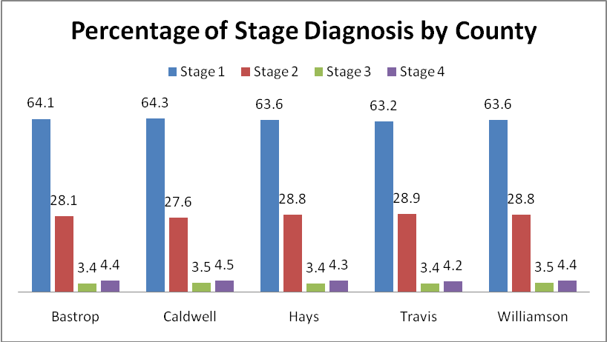
Data: Thomson Reuters © 2007

In continuing to break down this data by ethnicity, Black women are diagnosed the latest and therefore have poorer outcomes. This is pictorally represented by Table 2 below.

Table 2: Incidence Rate by Stage and Ethnicity
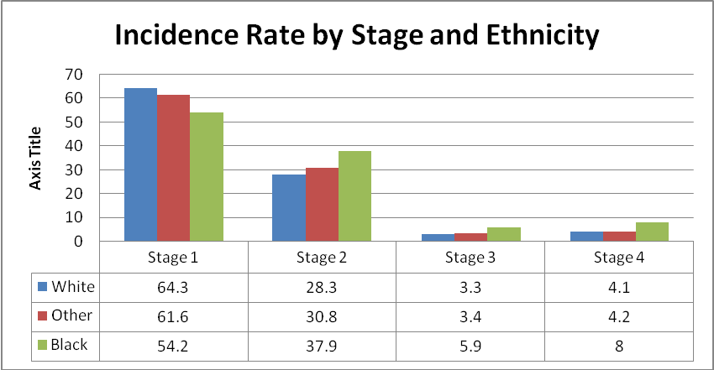
Data: Thomson Reuters © 2007

Caldwell and Bastrop Counties have the highest percentages Stage 4 diagnoses which the education, poverty rate and unisured data would predict.

Program and Services:
Nine medical facilities were identified within the Travis County borders which serve as a point of first contact for indigent women needing breast health care. This includes two hospital networks (each with several locations), Travis County Community Health Clinics, and four other primary health clinics offering services to under and uninsured individuals. Shivers Cancer Center, which partners with Austin Cancer Center, is the primary facility for cancer treatment in Travis County to the poor and uninsured individuals. In addition, there are numerous organizations which exist for the purpose of providing support and education to those affected by breast cancer. Two of the counties, Bastrop and Caldwell, have no cancer treatment options within their borders; treatment must be sought at the nearest facility located in either Travis or Hays County. Williamson County is now home to three hospital networks. Two hospitals have opened in Cedar Park in the past two years, increasing options for in-county care. In addition to these, three organizations were identified as being a point of first contact for indigent individuals.

Only one organization is established as a Breast and Cervical Cancer Control Program (BCCCP) provider in Travis County, two organizations are established as providers in Caldwell and one is established as a provider in Bastrop, Hays and Williamson Counties. This program provides state money to agencies for free screenings, case management to women with suspicious findings after a mammogram and for medical treatment after a diagnosis.

Screenings are provided by the mobile mammography unit, which is based in Travis County. The mobile unit is in high demand and serves the entire Komen Austin Affiliate service area.

The Hispanic population in the five county service area continues to grow as many move here to find jobs or join existing family members. While great gains have been made by the Austin Affiliate grantees in reaching this population, data from the 2006 Behavioral Risk Factor Surveillance System of the CDC shows that Hispanic women are still lagging other ethnic groups in screening mammograms. Six hundred twenty-eight women were contacted by phone and of this number, 202 Hispanic women reported that they had not had a mammogram in the past two years. These women are forty and older.

The challenges facing the Austin Affiliate are simply that demand has outstripped services. The current economic times resulted in less money for grantees during the 2009/2010 cycle and as a result, several services were cut back: the mobile mammography unit had to cut over 20 locations out of its schedule; more and more women are calling the office needing free screenings; many have lost their insurance and are in treatment. Everyday expenses have become more difficult for many, but especially for women battling breast cancer. Many of the Affiliate grantees have been advised to start looking for additional funding for their programs as economic times remain unpredictable at best. Williamson County is faced with a shortage of surgeons willing to see uninsured patients and the list grows as that population grows.
Community Data:

Focus groups, online surveys to community organizations and interviews with current Komen Austin grantees revealed a number of key findings with regards to breast health in the five county service area. Themes that emerged related to fear of breast cancer diagnosis and treatment, the method of communicating the importance of breast health care to different populations, body image, flexible transporation, the lack of breast surgeons willing to see indigent women and options for young women who reported finding suspicious lumps. The discovery of this information during the data gathering portion of writing the Community Profile has critical implications because it determines the direction the Austin Affiliate will take in the next several years and who the Affiliate will award grant funds to for the 2010/2011 cycle of funding. From the fourteen grantee interviews, the seven Survey Monkey questionnaires returned and five focus groups, the information, while some were similar to past years responces (transportation, fears of being diagnosed or not wanting to know), others were completely new (body image issues of seeing a physician and weight being the focus of discussion, young women not feeling empowered to discuss a suspicious finding at a college clinic). Black women, again, are the focus of great concern especially the stage of diagnosis and their mortality rates. As shown above in Chart 2, the poorer counties of Bastrop and Caldwell have the worst outcomes for these women. Bastrop County is home to the largest percentage of Black women in the Affiliate service area and their numbers continue to disappoint.

Recommendations:

Based on the findings of the Community Profile from data gathered from interviews and research, the Austin Affiliate developed priorties which align with their strategic plan. The Strategic Plan will be used to improve and guide the grant process and education programs for Komen Austin in the next several years. These priorities include:

- reducing breast cancer morbidity and mortality in the Black community for the entire five county service area;
- increasing the screening rates for Hispanic women;
- and reducing mortality rates in rural counties.

For a copy of the Strategic Plan, please visit our website at www.komenaustin.org or contact the Affiliate directly at 512.473.0900 for more information.

Introduction

About the History of Komen Austin

Nancy G. Brinker promised her dying sister, Susan G. Komen, she would do everything in her power to end breast cancer forever. In 1982, that promise became the Susan G. Komen Breast Cancer Foundation and launched the global breast cancer movement. While our name has changed to Susan G. Komen for the Cure, the Promise remains the same. Today, Komen for the Cure is the world’s largest grassroots network of breast cancer survivors and activists fighting to save lives, empower people, ensure quality care for all and energize science to find the cures. Thanks to events like the Komen Race for the Cure, we have invested nearly $1 billion to fulfill our promise, becoming the largest source of nonprofit funds dedicated to the fight against breast cancer in the world.

The Austin Affiliate of Susan G. Komen for the Cure was established in 1999 to spread the life-saving message of early detection and to support breast cancer screening, education, and treatment programs in Central Texas. The first Race for the Cure was held in Austin in November of 1997, and the Affiliate has granted over $5M since 1999 to fund these programs. In 2001, Ramona Magid was added as Executive Director of the Komen Austin affiliate to sustain the efforts created by the first race and many hours of volunteer service. Komen for the Cure Austin Affiliate celebrated its 10 year anniversary in 2009. The Austin Affiliate serves a five county area including Travis, Williamson, Hays, Bastrop and Caldwell counties.

This report is intended to serve as a roadmap to the services currently funded and gaps in those services for the five county service area. It is also intended to outline program plans on how the Affiliate will seek to meet the needs of the identified groups which should lead to change in behavior and reduced breast cancer mortality. Paramount to this effort is the creation of the Austin Affiliate’s Strategic Plan would can be found in the Appendix of this document.

Austin Affiliate
Service Area

cece Area

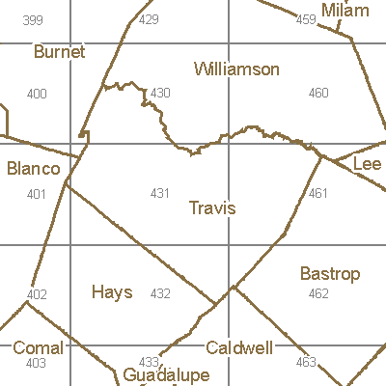

Williamson - Cedar Park, Florence, Georgetown, Granger, Hutto, Jarrell, Leander, Round Rock, Taylor, Thrall
Travis - Austin, Del Valle, Garfield, Jollyville, Jonestown, Lago Vista, Lakeway, Manchaca, Manor, Pflugerville, Rollingwood, West Lake Hills
Hays - Buda, Driftwood, Dripping Springs, Kyle, San Marcos, Wimberley
Caldwell - Dale, Lockhart, Luling, Martindale, Niederwald, Uhland, Maxwell
Bastrop - Bastrop, Cedar Creek, Elgin, Paige, Smithville
Demographic & Breast Cancer Statistics

Data Source & Methodology Overview

In examining demographic and breast cancer data and statistics in the Austin Affiliate’s five county service area, a number of sources were researched and utilized. The sources used for the Profile, include but were not limited to, Texas Cancer Registry, Thomson Reuters © 2007, NCI, and Cancer Control P.L.A.N.E.T. Data was also gleaned from the County Information Project, an initiative of the Texas Association of Counties, provided further data on each county’s demographics and geography. In the process of researching and obtaining breast health statistics, both the Texas Cancer Registry and the Behavioral Risk Factor Surveillance System (BRFSS) were very helpful in providing vital information for the profile process. In addition, Cancer Control P.L.A.N.E.T. and The National Cancer Institute each provided supplementary, informative data throughout the community profile process. The methodology for data collected included face-to-face interviews with the 2008/2009 slate of grantees; Survey Monkey questionnaires to non-grantee providers in the five county service area and six focus groups consisting of women from the service area who had not received services from the any of the Komen Affiliate grantee pool and were not aware of the serviced provided by Komen Austin. The women in these focus groups were from various age brackets, varying ethnicities, varied socio-economic status; they all shared the commonality of being uninsured.

Demographics

The Austin Affiliate’s service area encompasses five counties in the central Texas area comprised of Bastrop, Caldwell, Hays, Travis and Williamson. Including rural, suburban and urban areas, these counties each provide unique challenges and opportunities in breast health care. Just over 49% of the service area’s 1.5 million residents are women, and over half a million of these women are 40 years and older, the targeted age for breast cancer screening. Based on data provided by Thomson Reuters © 2007 and the 2007 County Information Project, the following table shows a population comparison in each of the Austin Affiliate’s counties.

Table 3. POPULATION BY AGE PER COUNTY, 2007
 | Total Population | Female Pop | Female Pop  20-39 | Female Pop  40-64 | Female Pop 65 and older | Persons per Square Mile* | Land Area (sq miles)*
Texas | 23,904,380 | 50.10% |  |  |  | 79.6 | 261797
Bastrop | 72,727 | 49.40% | 9,805 | 5,663 | 2,467 | 65.0 | 888
Caldwell | 38,936 | 50.40% | 5,682 | 11,604 | 4,041 | 59.0 | 546
Hays | 144,641 | 49.80% | 25,505 | 20,400 | 6,721 | 143.9 | 678
Travis | 903,041 | 48.90% | 146,110 | 139,578 | 39,722 | 821.3 | 989
Williamson | 354,978 | 49.90% | 53,072 | 55,721 | 15,570 | 222.4 | 1,124
Total for Service Area | 1,514,323 |  | 240,174 | 232,966 | 68,521 |  | 4,225
SOURCE: Thomson Reuters © 2007
*County Information Project, Texas Association of Counties

Table 3 shows the breakdown of information about each county as compared to the State of Texas. Caldwell is the smallest of the counties the Affiliate serves and is also the most rural. Williamson is the largest in geographic area followed by Travis. Bastrop County also contains a large rural setting as 68% of its residents reside in two towns, Bastrop and Smithville. Because of the rural nature of Bastrop and Caldwell, coupled with the large number of women over the age of 40 as seen in Table 3, these areas are vital to the success of the Austin Affiliate and our Mission of reducing breast cancer mortality and change behaviors long term. Another important element in achieving the Affiliate Mission of changing behaviors and reducing mortality, the Austin Affiliate grants funding to programs in the area targeting women within a wide age range. Screenings are certainly focused towards women who are 40 years and older based on the knowledge that this age bracket in general is at a higher breast cancer risk; however, there is also an effort to provide services to younger women as well who need clinical breast exams. In the five county service area, there are approximately 473,140 women who are between the age of 20 and 65. Women 65 and older are eligible to receive Medicare benefits.

Race & Ethnicity

Based on 2007 Census data, the following table shows the breakdown of race and ethnicity in the Austin Affiliate counties.

Table 4. 2007 Population by Ethnicity
 | Total Population | %  White | % Hispanic | %  Black | % American Indian | % Asian/ Pacific Islander
Texas* | 23,904,380 | 47.90% | 36.00% | 12.00% | 0.7% | 3.4%
Bastrop | 72,727 | 63.40% | 26.10% | 8.30% | 0.40% | 0.60%
Caldwell | 38,936 | 46.30% | 44.80% | 7.00% | 0.30% | 1.00%
Hays | 144,641 | 60.50% | 33.50% | 3.60% | 0.40% | 0.90%
Travis | 903,041 | 51.70% | 32.60% | 8.00% | 0.30% | 5.50%
Williamson | 354,978 | 67.60% | 20.10% | 6.30% | 0.30% | 3.90%
Total: Service Area | 1,514,323 | 56.7% | 29.8% | 7.1% | .3% | 4.3%
SOURCE: Thomson Reuters © 2007
*County Information Project, Texas Association of Counties

Table 4 shows race and ethnicity of the service area. For the entire service area, whites make up the majority (56.7%) followed by Hispanics (29.3%) and Blacks are 7.1% of the population. The biggest change in race/ethnicity since the 2006 Profile was that Bastrop County Black population nearly double in percentage from 2005 to 2007 date (4.8% to 8.30%). It is important for the Austin Affiliate to take into careful consideration the race and ethnicity of those residing in the five county service area. There are unfortunate health disparities which continue to exist among those of certain populations, and recognition of the presence of these populations allows for culturally sensitive approaches to be taken in outreach efforts. The large numbers of college students also impacts the numbers for the Austin Affiliate. There are twelve accredited universities in the Austin Affiliate service and close to thirty other schools who teach technical/trades skills, others who provide culinary skills, and even others providing a service such as Home Health Aide certification or cosmetology. The population of young women according to Thomson Reuters © 2007 data states that the Austin Affiliate service area has a population of young women, 0-19 years of age, totalling over 1.5M, which accounts for 27.7% of the population served by the Affiliate. This is the largest percentage group of women by a factor of 10. Whether or not this data is skewed by University attendance is not clearly understood at this point since this population is transient. More work is needed to understand this population group needs to be done by the Austin Affiliate.

The Affiliate Service area is greatly influenced in some counties by the number of Universities and the degrees of their faculty. The more rural counites, such as Bastrop and Caldwell, do have lower percentages of college grants according to data from 2007 NCI as seen in Table 5 below. This gives a very good pictoral of the education levels by county. It is also documented that the health of a county is proportionate to education levels of this county. It would follow then that the health of Bastrop and Caldwell Counties would be poorer than those of the rest of the service area due to this data.

Table 5: Education Levels of Affiliate Service Area
Source: NCI Thomson Healthcare © 2007

Poverty Statistics

Direct correlations between economic status and the overall health of populations have been repeatedly proven throughout innumerable studies. It is therefore imperative to understand the socioeconomic background of residents being targeted for education and outreach. Within the Austin Affiliate’s five county service area, there is a notable variance of economic statuses present per county, ranging from only 6% of the population living at the poverty level in Williamson County to a much larger 19% in Caldwell County. Table 6 below shows the varying degrees of poverty by county as compared to the State of Texas. Caldwell County is the poorest county in the service area and has suffered as a result of this because preventative health is not considered when basic needs such as food and shelter are a struggle.

Table 6: Poverty by County, 2007
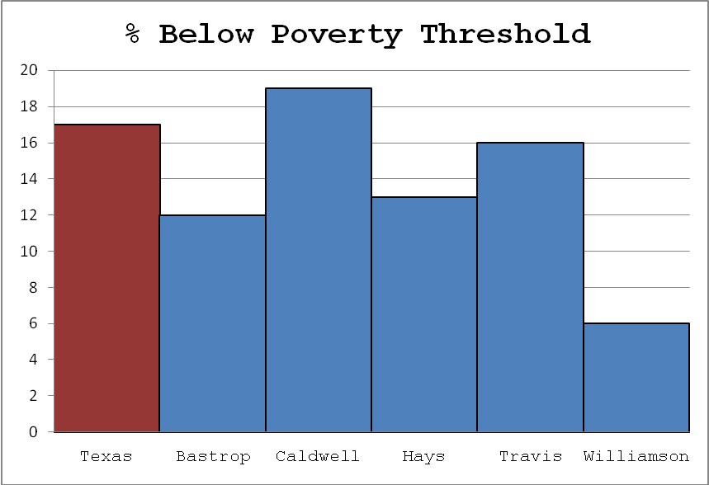
SOURCE: County Information Project, Texas Association of Counties

The State of Texas provides Medicaid for Breast and Cervical Cancer (MBCC) for women living at or below 200% of the poverty level who also meet diagnosis, residential, and age requirements. While the specific number of women and households who live at this economic level is difficult to pinpoint, it certainly encompasses a large population of people within the five county service area. The table found in the Appendix shows how the approximate income is used in qualifying families. To understand the poverty calculations, please visit the Appendix of this document.

Uninsured Data

Awareness of the number of uninsured residents is also an incredibly important piece of information in understanding the state of overall health of a particular geographic region. According to the Texas Medical Association 2007, the state of Texas has the highest rate of uninsured residents based on a two year average (2005-2007). Twenty-five point seven percent (25.7%) of Texans are uninsured, which is eight percentage points higher than the national average (16%). In comparison, Florida has an uninsured rate of 20%, California 19% and New York 13%.

Table 7 describes the uninsured rate for the service area along with other factors about the Austin MSA (Metropolitan Statistical Area) provided by the US Census Bureau. Table 6 shows that with the exception of Caldwell County, the service area is below the State’s average for the population of each county as a whole. In the Komen Austin Affiliate service area, it is interesting to note that Williamson County, which has the lowest poverty rate, has the second highest uninsured rate, 21.2%. Caldwell County tops the list of the five county service area with the most uninsured individuals at 23.9%. What is interesting to note, however, is that females between the ages of 18 – 64 for four of the counties, excluding Williamson, have percentages of uninsured ranging from 22.4% (Bastrop) to 29.9% (Hays) according to Thomson Reuters © 2007 data. Again, we are not clear if the data is skewed by University students who attend one of the many colleges in the area.

In the midst of the current economic atmosphere, the uninsured rate will continue to increase unless healthcare changes are made.

Table 7: Behavioral Risk Factor Surveillance Survey, 2007
Texas BRFSS 2007
Risk Factor: No Health Insurance
Area: Austin-Round Rock MSA
 | Sample | % at risk | 95% CI
 | Size* | % at risk | Lower | Upper
Nationwide | 429,769 | 15.3 | 15.0 | 15.6
Texas | 17,177 | 25.7 | 24.6 | 26.8
Austin-Round Rock MSA | 1,374 | 18.7 | 15.8 | 22.0
Gender
Male | 506 | 17.4 | 13.1 | 22.9
Female | 868 | 20.1 | 16.8 | 24.0
Race/Ethnicity
White | 1,025 | 11.6 | 9.1 | 14.7
Black | 88 | 17.3 | 8.0 | 33.3
Hispanic | 201 | 37.2 | 29.1 | 46.0
Age Group
18-29 Years | 115 | 28.8 | 20.2 | 39.2
30-44 Years | 373 | 21.4 | 16.4 | 27.5
45-64 Years | 550 | 14.4 | 11.1 | 18.5
65+ Years | 324 | 4.6 | 2.2 | 9.2
Education
No High School Diploma | 114 | 50.7 | 38.4 | 62.9
H. S. Graduate | 265 | 19.9 | 13.7 | 28.0
Some College | 364 | 21.9 | 16.1 | 29.1
College + | 628 | 8.5 | 6.2 | 11.7
Income
Less Than $25,000 | 259 | 47.4 | 39.0 | 55.9
$25,000 thru $49,999 | 288 | 18.7 | 12.8 | 26.5
$50,000 or more | 650 | 5.2 | 3.2 | 8.5
Notes
Respondents 18 years and older who report that they have no health insurance.
The '-' indicates that the sample size was < 50.
*The sample size includes all survey respondents except those with missing, "don't know", or "refused" answers.

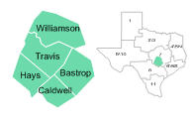

Breast Cancer Statistics

Expected Numbers of Cancer Cases and Deaths
For 2009, 841 new cases of breast cancer are estimated in Travis, Williamson and Hays Counties. Due to lower populations in Caldwell and Bastrop Counties, estimates are unavailable. The data for comparison came from the Texas Cancer Registry Data for 2009. A breakdown by county is available in Table 8.

Table 8: Incidence and Mortality by County, 2009
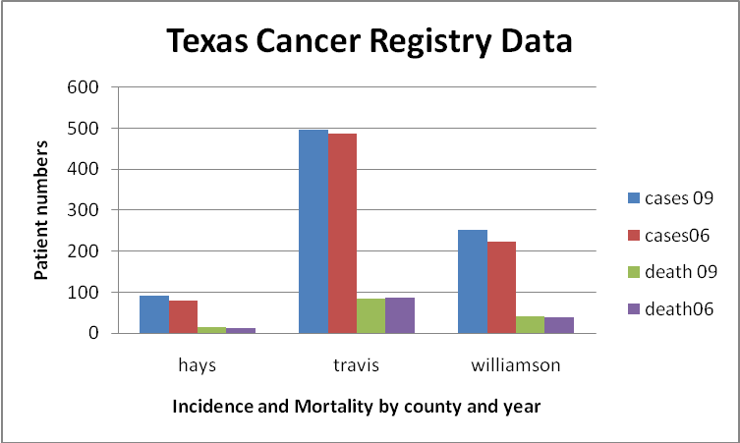
Source: Texas Cancer Registry, 2009

This data also points out that the incidence rate of 2009 is slightly higher than that of 2006. There are multiple reasons why this is showing in the data: increases in population, more women are getting screened, etc. According to the National Cancer Institute’s State Cancer Profiles, breast cancer mortality in the state of Texas has been steadily declining throughout the past several years. Unfortunately this doesn’t track with the three counties profiled in Table 8. Table 9 gives the breakdown by county of incidence. Incidence is a measure of the number of people per 100,000 people within a specified time period and population that has been diagnosed with the disease.

Table 9: Incidence by Service Area County
 | Breast Cancer Incidence, 2001-2005
 |  | Texas | Bastrop | Caldwell | Hays | Travis | Williamson
 | All Races | 115.5 | 188.8 | 114 | 126 | 130.2 | 117
 | White | 115.4 | 115.8 | 118 | 122.8 | 129.8 | 119.9
 | Hispanic | 84.6 | 66.3 | 92 | 131.9 | 83.6 | 77.3
 | Black | 116.2 | 132.3 | 41.1 | 150.1 | 120.5 | 71.3
Rates are per 100,000 and age-adjusted to the 2000 US Standard Population (19 age groups-Census P25-1130).
Cases are the total 5 year period, 2001-2005.
Source: Texas Department of State Health Services, Cancer Epidemiology and Surveillance Branch, Texas Cancer Registry, 1995-2005 Incidence.

The mortality rate is defined as:

Deaths from breast cancer
Per 100,000 people within a specified
time period and population
The mortality rates for the service area also track according to education and poverty stats as shown in Table 10. Caldwell County has the lowest education rating and is the poorest county and unfortunately the mortality statistics track right along with this. The very disheartening part of this is that Caldwell County has the lowest rate of incidence among the five counties, but has the highest mortality rate.

Table 10: Mortality by Service Area County
Breast Cancer Mortality, 2001-2005
 |  | Texas | Bastrop | Caldwell | Hays | Travis | Williamson
 | All Races | 23.8 | 26.4 | 30.6 | 25.8 | 23.9 | 20.1
 | White | 22.9 | 23.2 | 31.5 | 26.7 | 24 | 19.9
 | Hispanic | 17.2 | 2.9 | 21.5 | 24.6 | 17.6 | 10.5
 | Black | 35.6 | 68.2 | 22.7 | 0 | 29.8 | 39
 | Asian/Pacific Islander | 8.6 | 0 | 0 | 0 | 6.2 | 4.1
 | American Indian/Alaskan Nat | 3.7 | 0 | 0 | 0 | 17.6 | 0
Rates are per 100,000 and age-adjusted to the 2000 US Standard Population (19 age groups – Census P25-1130).
Deaths are for the total 5 year period, 2001-2005.
Rates for the white race are given separately for Hispanic whites and non-Hispanic whites.
Hispanic ethnicity is not mutually exclusive from whites, blacks, Asian/Pacific Islanders, and American Indians/Alaskan Natives or other race groupings.
Population data are based on the U.S. Census Bureau’s Population Estimates Program, and modified by the N.C.I. using the special processing procedures for the counties affected
By Hurricane’s Rita and Katrina. This is described on the SEER website: http://seer.cancer.gov/popdata/

Cancer Control P.L.A.N.E.T. provides further data regarding breast health care, revealing that in 2006, 71% of Texas women over the age of 40 and 75.1% over the age 50 had a mammogram within the past two years, meeting the Healthy People 2010 objective.

Tables 11 and 12 from the Behavioral Risk Factor Surveillance System of the CDC reveal mammogram rates in women over the age of 40 in the State of Texas. Unfortunately this data was not provided per county. It is important to consider that the data for this survey was gathered via phone interviews, and that a relatively small number of Black women were contacted. This could cause a misleading skew in the data. Of the three groups, Hispanics have made the smallest gains in screening rates and the Austin Affiliate will address this by placing emphasis on getting these numbers up.

Table 11: Women Aged 40+ Who Have Had a Mammogram within the Past Two Years, BRFSS Data, Texas 2004
Race: |  | Yes | No
White | % (CI) n | 71.3 (68.7-73.9)  1170 | 28.7 (26.1-31.3)  469
Black | % (CI) n | 66.9 (58.5-75.3)  106 | 33.1 (24.7-41.5)  66
Hispanic | % (CI) n | 60.4 (55.0-65.8)  322 | 39.6 (34.2-45.0)  206
% = Percentage, CI = Confidence Interval, n = Cell Size
Percentages are weighted to population characteristics.

Table 12: Women Aged 40+ Who Have Had a Mammogram within the Past Two Years, BRFSS Data, Texas 2006
Race: |  | Yes | No
White | % (CI) n | 72.9 (69.5-76.3)  1548 | 27.1 (23.7-30.5)  499
Black | % (CI) n | 78.9 (71.9-85.9)  218 | 21.1 (14.1-28.1)  66
Hispanic | % (CI) n | 61.6 (55.8-67.4)  426 | 38.4 (32.6-44.2)  202
% = Percentage, CI = Confidence Interval, n = Cell Size
Percentages are weighted to population characteristics.

Table 13: Mortality Rates by Ethnicity
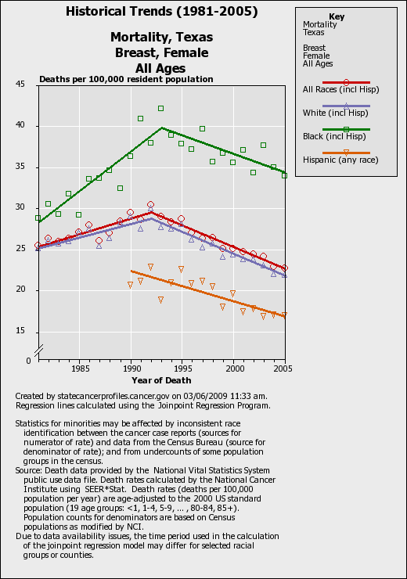
Source: NIH, 2009

Table 13 speaks to the heart of the data compiled by the Austin Affiliate for 2009 and the core of priorities that surround the Black population. Black women in the service area continue to die at an alarming rates from breast cancer. Caucasian women continue to be diagnosed at a much higher rate, but do not suffer the mortality of their Black peers. The numbers are going down, but the delta between the rates has not decreased.

Programs and Services

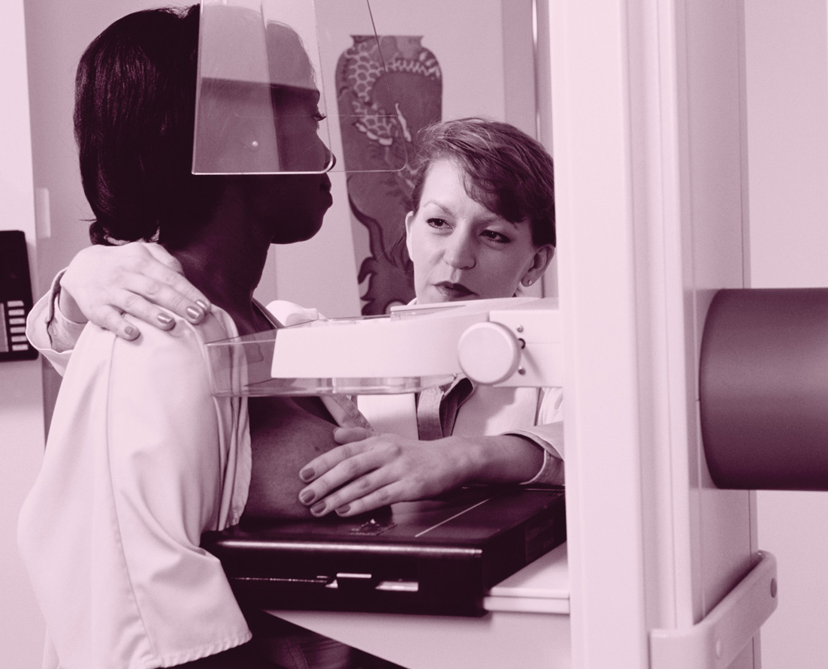

Data Source and Methodology

In an attempt to obtain an understanding of the programs and services in the Austin Affiliate’s five county service area, the preliminary process of creating an asset map was started by generating a chart with all of the breast health service providers in the five counties. Upon completion, the asset map will visually illustrate the location and services of all the breast cancer screening and treatment programs available for women in the Komen Austin Affiliate service area.

Several sources were utilized in completing this chart including a list of current Komen Austin grantees, hospitals and a thorough report previously completed by Breast Cancer Services in the summer of 2008, which documented the entire known medical and social service breast health providers in the Austin area.

Once the list was created, the providers were categorized accordingly with the following labels:

- Point of 1st Contact
- Education
- Screening
- Coordination of Care
- Diagnosis
- Treatment
- Support
- Advocacy

An official map of the services provided will be complete and available after the announcement of the Austin Affiliate’s 2009/2010 grantees.

Contact was made with each of the Austin Affiliate 2008 grantees as well as with multiple service providers not affiliated with Susan G. Komen in order to gain a better understanding of the services available to women in the service area.

Programs and Services Overview

The majority of the breast health programs available in the Austin Affiliate service area are in the more geographically metropolitan areas. A complete chart listing the locations and services of breast health programs in the Komen Austin service area can be found in the appendix.
- Travis County
  - Nine medical facilities were identified within the Travis County borders which serve as a point of first contact for indigent women needing breast health care.
  - This includes two hospital networks (each with several locations), Travis County Community Health Clinics.
  - Four other primary health clinics offering services to under and uninsured individuals. Shivers Cancer Center, which partners with Austin Cancer Center, is the primary facility for cancer treatment in Travis County to the poor and uninsured individuals.
  - In addition, there are numerous organizations which exist for the purpose of providing support and education to those affected by breast cancer.
  - Two new hospitals are scheduled to open in 2010 in the Lakeway, TX area which is located in Western Travis County.
  - There is only one BCCCEP provider for the entire county. They are currently merging with the City of Austin and their future with Komen Austin is unclear.
- Williamson County:
  - Two new hospitals have opened since the 2006 Community Profile. The newest, Seton Williamson County has an excellent breast imaging center and is becoming a valued resource in this growing county. Williamson is currently home now to a total six hospitals and other major screening providers.
  - The only BCCCEP provider here is a branch of a Hays County grantee, Community Action
- Bastrop County:
  - One new hospital has joined the ranks there: Lakeside Hospital. There is discussion that Lone Star Oncology may be setting up practice there. There are currently no treatment facilities in this county. There is a small in Smithfield, one of the largest cities in this county. Women still come to Hays or Travis for screening, diagnostics and any form of treatment.
  - There is a new grantee here that will be the BCCCEP provider for this county.
- Caldwell County:
  - Caldwell has a small 21 bed hospital that currently does no cancer treatment of any kind. There are currently no plans to add this service for the people of this county. Screening mammography is the only service and if a suspicious finding is located, the patient is sent to Hays or Travis County.
  - Four grantees are serving this county currently and two of these are BCCCEP providers
- Hays County:
  - There is one new hospital that is planning to open in the fall of 2009 which brings the total to two. They will offer treatment at every level for the women of Hays County.
  - Hays currently has excellent services for women. There are many providers in Hays County for screenings, but many of the uninsured patients come to Travis.
  - Community Action is the sole provider of BCCCEP services for Hays County.

BCCCEP provides state money to agencies for free screenings, case management to women with suspicious findings after a mammogram and for medical treatment after a diagnosis.

Screenings are provided by the mobile mammography unit, which is based in Travis County. The mobile unit is in high demand and serves the entire Komen Austin Affiliate service area. They will be visiting over 115 locations in 2009 to meet the growing demands of the service area.

Within several organizations promoting breast health to the Hispanic, Spanish-speaking community, there exists effective education programs partnered with mobile mammography and a system for follow up care if needed. These programs in both Hays and Travis Counties have increased the number of positive relationships with the Spanish-speaking community; increasing levels of word of mouth referrals within the community highlights the fact that the breast health message is well received and understood.

Public Policy
The public policy efforts at the Austin Affiliate of Susan G Komen for the Cure have led to great outcomes for the Affiliate and for all Texans. The Austin Affiliate covers two of the three counties (Hays and Caldwell) in District 45 represented by Patrick Rose. Representative Rose has been instrumental in helping the Austin Affiate work with agencies and elected officials from both these counties and others to increase the number of women who get breast health information and screenings. Representative Rose was also the co-author of HB14 which ultimately was merged with the Senate version to become Proposition 15 which was passed by the voters of Texas in 2007. The Cancer Prevention and Research Institute (CPRIT) was founded in 2008 and Patrick Rose and Senator Jane Nelson became the first ever recepients of the Susan G Komen “National Legislator of the Year” award in February 2008. Patrick Rose is the Chairman of the House Human Services Committee.

The Affiliate has a close working relationship with Representatives Donna Howard, Valinda Bolton,Dawnna Dukes,Elliott Naishtat,Eddie Rodriquez, and Mark Strama. We will continue to work with this group of elected officials as the need arises. We have also worked closely with Senators Kirk Watson and Jeff Wentworth. Representative Naishtat serves as Vice-Chair of the Public Health committee and is a member of the Human Services Committee. Representative Dukes is the Vice-Chair of the Appropriations committee.

In Bastrop County, Tim Kleinschmidt is now the Bastrop County representative for the House and the Austin Affiliate will seek to work with him as we secure goals for 2009 in Bastrop County. Efforts need to be made to work with the elected officials in Bastrop county to work towards a relationship that extends into the county government as well as the elected officials of each major rural town in Bastrop County. This would hopefully open up the dialogue of how resources are being utilized for the women of this county and where Komen Austin dollars could be spent more effectively.

Williamson County is a county that will also need attention this year, 2009, in the political arena. Diana Maldonado is a newcomer this year to this position. Dan Gattis, of Williamson County, has much experience and has been very supportive of the Affiliate efforts thus far.

The efforts of the Austin Affiliate on the state level continues to be an important one for the women of Central Texas. In the 2009 Legislative Session, a combined bill to require insurance companies to pay for the costs of clinical trials previously paid for by the patient is on Governor Perry’s desk for signature. Insurance companies also cannot drop a patient participating in a clinical trial if the Governor signs the Bill. Funding for CPRIT (Cancer Prevention and Research Institute of Texas) also came in lower than requested at $450M versus the $600M requested. This means there will be fewer dollars to put into research and screening in 2010. It is clear that efforts by the Austin Affiliate have an impact on what happens at the state level and those efforts will be continued as budgets are tightened at the State level.

Exploratory Data



Sources and Methodology

Each of Komen Austin’s current 2008 grantees was contacted to set up an interview regarding their services, target populations, challenges and strengths. They were all interviewed using the same outline of questions. This information can be found in the Appendix of this document.

In addition, ten Google-based online surveys were emailed to various service providers within the five counties who receive no grant funds from Komen Austin. These surveys were a learning process as it took a few weeks to realize the link from the website resulted in sporadic receipt of the survey whereas emailing with a direct link was much more successful. Of the surveys emailed, six responses were gathered; there were no responses from contacts in Caldwell County. At least one representative organization from each of the other counties responded. Six focus groups were also held to gather information from women in the community. Each of the focus groups consisted of 5- 8 participants and were approximately two hours in length. Explanations were given to each of the women about the process and why we were doing the interviews. The women were chosen because of their limited knowledge about the Austin Affiliate and the services provided. All of these women were uninsured. It was also important that the ethnic groups served by the Affiliate were represented in the focus groups. One Spanish speaking group was held in Hays County with the help of a Komen grantee and the remaining five were held in Travis County through the Austin Affiliate’s Wise Women program. Four of the focus groups were predominantly Hispanic; two were mainly Black and Asian in make up. Each of the focus groups followed the same outline of questions and was facilitated by the same person in order to allow for consistency in the collection of desired information. For a list of questions, please look in the Appendix of this document.

Overview and Findings

A number of relevant themes and key findings were noted with the collection of information from grantee interviews, focus groups and survey responses.

Common responses to why women aren’t seeking breast health screening are as follows:

• Fear came up often as anticipated. This includes fear of breast cancer itself, fear of treatment or fear of being treated differently due to a suspicious lump or a cancer diagnosis. One respondent quoted a client as bluntly stating: “I don’t want to know [if I have cancer].” Another ascribed to a “what you don’t know can’t hurt you” theory. Still another woman refused to follow up for treatment because a radiology technician described in vivid detail the process that she would need to undergo to have a breast biopsy. The knowledge and fear of the surgery process was preventing this woman from taking care of their health.

• Cultural sensitivity is imperative. Two representatives from organizations working with recently immigrated populations both noted the barrier of husbands not wanting other people to touch their wives’ bodies in the course of medical treatment. And vice versa, many of the recently immigrated women also feel reluctant to allow anyone but her husband to touch her body. Understanding of such cultural influences are incredibly important for this Spanish-speaking population as well as for the GLBT population, the growing population of Asian women and other non-majority groups present in the community.

• Many responses given as to why breast health screenings are not pursued revolve around the theme of there being “too many other things to worry about.” Women in the focus groups and organizations interviewed stated that women continually place family and jobs in front of their own health; making time to schedule a mammogram around work schedules and children and a husband to care for is often a difficult task.

• The absence of public transportation in Bastrop, Caldwell, Hays and Williamson Counties creates a challenge for women needing to travel to screenings and cancer treatment, particularly in Bastrop and Caldwell where there are no in-county options for treatment.

- Many women under 40 do not receive yearly clinical breast exams due to the inability to pay for the doctor’s appointment. In addition, as a result of conversations with local university students, young college aged women feel that many University Health Centers do not seriously consider breast cancer as a possibility in young women with breast complaints. Body image was a theme in the focus groups of all ethnicities. More than one woman brought up the fact that her obesity prevented her from getting clinical breast exams and/or regular mammograms due to embarrassment of disrobing in front of medical personnel. Women discussing this particular issue felt that other health issues relating back to their obesity would be elevated to a higher level by medical professionals than would their breast exams; these women were afraid of being “preached at” about their weight and therefore have decided they would prefer not to schedule these appointments.

- Several themes emerged in the African American focus group were: Body image; multiple women spoke of their primary priority in caring for their bodies as being to “find a man” and not necessarily to be healthy. Other themes were: not knowing their family history as breast cancer wasn’t discussed openly; a matriarchal order to how things are done; a lack of family history is a reason not to pursue breast cancer screening services.

  - A positive finding from the focus groups and in discussion with Komen Austin grantees is that the Hispanic population has been very receptive to the message of breast health care when shared in a personal, door-to-door method. Several organizations working with the Spanish-speaking populations in Travis and Hays Counties noted improvements in knowledge about breast health and behavior and have noted an increase in women seeking services due to word-of-mouth referrals. One organization stated that they have been overwhelmed by walk-in clients due to women hearing about their services from other community members. This method of getting the message of breast health has been extremely effective, and therefore it is noted that this method should be replicated for different populations.

• One organization contacted works specifically with the GLBT (Gay, Lesbian, Bi-sexual, and Transgender) population in the Austin area and partners with the mobile mammography unit. This organization shared that it is a concern that women of this population and are unlikely to seek breast health treatment on their own due to “insensitive gender expressions” with service providers, which highlights the fact the there certainly needs to be a sensitivity to this group. In addition, it was noted that, while gay and bi-sexual women are able to receive screenings through their partnership with the mobile mammography unit, transgender women are not able to be served.

- Patient navigation, or a personal and directed method of guiding women though the medical system after a cancer diagnosis and for follow up is a recognized need by most grantees in the breast health service arena.

- Another finding is the underutilization of Emergency Medicaid available to qualifying women. With a breast cancer diagnosis, if a woman is over 18, a legal resident, uninsured and living below 200% of the poverty line, she is eligible to be enrolled in Emergency Medicaid which will cover any health concern she has, not solely her cancer treatment.

- A need for emergency room staff to be aware of the Emergency Medicaid option has been noted so that women needing breast health services after finding a lump can be re-routed out of the hospital and to private physicians, therefore lightening the load on hospital emergency rooms.

Conclusions
In reviewing the findings for the 2009 Community Profile, there are issues and concerns that have been thematic throughout every profile written for the Austin Affiliate to date. These include, but aren’t limited to: lack of flexible transportation (transportation to and from screenings and medical appointments that is able to be scheduled or changed within a day or two if necessary), fear of a cancer diagnosis, not having the funds to pay for screening and/or treatment, the limited number of clinics, which translates into a long wait time in order to see a doctor, prioritizing other, more pressing needs above healthcare, and simply not taking the time to get screenings.

County Findings:

Caldwell County:

- As was evident in the 2006 Community Profile, Caldwell County continues to stand out as one needing special attention in regards to breast health. According to data obtained from the Texas Cancer Registry (2001-2005), Caldwell County ranks fifth among the five counties in breast cancer incidence but first in mortality. Thomson Reuters © 2007 and State Cancer Profile data provide slightly different statistics, but each confirms the fact that rural Caldwell County has the highest age-adjusted mortality rate.
- In addition, Caldwell also stands out as having the highest poverty rate and being the most rural (as evidenced by persons per square mile). Another notable finding regarding Caldwell County is that there are virtually equal numbers of Caucasian and Hispanic populations, whereas in each of the other counties there is a clear majority Caucasian population.
- In addition to the discouraging demographic information and statistics, Caldwell County has a lack of medical options available for cancer care. Women needing biopsies and/or who are diagnosed with breast cancer must travel either to Travis or Hays County to receive treatment, regardless of insurance status. Two facilities are available for women as a point of first contact to receive clinical breast exams or screenings and a couple others also provide educational materials for breast health.
- Due to these circumstances, Caldwell County was targeted by the Austin Affiliate in the 2006 Community Profile, and breast health programs were set in place in an attempt to counter these statistics. Efforts were made to get women in for screenings and raise awareness by “Painting Caldwell Pink” in October 2007 and 2008. This program was embraced by local government and elected officials and continues to be supported in Caldwell County to date with local grantee, local business and government participation.

Bastrop County:

- It also seems noteworthy to mention the fact that Bastrop, a rural county, is home to a larger population of Black women than any of the other counties.
- Bastrop County is also sadly lacking in cancer treatment options; diagnosed women must travel to a neighboring county to receive chemotherapy or radiation.
- The demographic and breast cancer data also highlight notable, yet expected findings among the Black population and Bastrop County is now home to the largest percentage of Blacks in the service area. Because of the mortality rate of Black women, Bastrop County is being targeted in 2009/2010 as was Caldwell to start a grassroots effort of recruiting local women to champion the efforts there along with a grantee.

Hays County:

- A significant proportion of every one of the Austin Affiliate’s counties is Hispanic and Hays County has the largest growth for this group.
- This steadily growing population in Central Texas is a critical factor in planning for effective breast health education and services. More than just knowledge of the significance of this population, there is a definite need to understand the cultural influences and differences between those in this population that are newly immigrated and those who have been a part of the Austin area for quite some time in order to provide culturally competent services to each.
- In particular, northern Hays County and Caldwell County are known
to have large populations of recently immigrated, largely
undocumented individuals. Neither of these areas has sufficient
options for affordable healthcare to the indigent.
- With the opening of Seton Hospital in northern Hays County in 2009, it is hoped that more opportunities for affordable care will become available.

Travis County:
- Larger numbers of uninsured patients are being seen as employers lay off and unemployment numbers continue to rise.
- One clinic run by the City of Austin is closing and is being reopened in a location that is less convenient to the patients it is to serve.
- Waiting times at MAP (Medical Assistance Program) clinics run by the City of Austin continue to climb

Williamson County:
- Two new hospitals have opened and are offering breast health services to residents
- An issue with lack of breast surgeons has been resolved.
Focus Group Findings:

- Black populations continue to have the highest mortality rate of any ethnic group and, based on interviews, some of the efforts to curb this are ineffective. In many of the focus groups and in discussions with young women of color, it is evident that there exists a matriarchal order to how things are done. One focus group member stated that, “If my Auntie doesn’t think I need one and if she isn’t getting one, I’m not going to either.”
- Through focus groups, it was also discovered that it seems as though those in the African American community use a lack of family history as another reason not to pursue breast cancer screening services. This message has been prominently used in the “risks” category when talking about breast cancer, and therefore if there has been no known family history, the thought of screening is downplayed.
- Another finding from the focus groups is the reluctance or refusal of Black women to reveal a breast cancer diagnosis. It was heard many times over that many of the women in African American families did NOT know what female family members died until many years later. This “hiding” of family history has also been observed by our grantees throughout the years. Lack of dialogue and discussion of breast cancer in this particular population in the Austin area is still an issue due in part to its sexual nature.
- In several of the focus groups, young Black women stated that they needed to keep their bodies healthy in order to attract a man; and deformed or non-existent breasts will keep men from wanting them.
- According to Ruby Payne, author of the very poignant book, “Bridges out of Poverty,” hidden rules exist in populations where poverty is a way of life. Much of what was heard in the focus groups during the completion of this Community Profile reflected the presence of these unspoken rules referenced by the author. These rules include:
  - The family structure tends to be matriarchal
  - Driving forces are relationships and survival
  - Decisions are made for the moment and based on feelings
  - Love and acceptance are conditional
  - People are possessions
  - Deep belief in fate and the idea that not much can be done to mitigate chance.

- Another finding is that Austin is attracting a large number of Middle Eastern families who are fleeing the war in Iraq and Pakistan. The Urdu language is now a need in many of the MAP (Medical Assistance Program) clinics.
- In addition, there are a large number of Hurricane Ike evacuees settling into the Austin area due to the fact that Galveston and Galveston Island have not been rebuilt following the hurricane of last fall. Many of these displaced individuals and families are still looking for work, housing, and are uninsured. There have also been some women in treatment who are settling in Austin and are now receiving treatment at Shivers.

- The Asian population continues to grow, and impressive efforts are being made through the churches that these groups attend. Yearly health fairs continue to be held at the Chinese American Church and at similar congregations attracting the Vietnamese populations. Also, excellent strides have been made in the Vietnamese population through the Wise Woman program. Many of these immigrants live in North Austin at the American Housing complexes where Wise Women have done an excellent job of educating and getting these women in for screenings. Cervical cancer is the number one killer of Vietnamese women, but this community of women in the Austin area is eager to actively take care of their health.

- Another population needing extra focus is college aged women. Through discussions with students and staff from several local Universities, a need has been identified to educate university health center physicians on the breast cancer risks of this population. The physicians do not seem to acknowledge breast cancer as a possible diagnosis within this age range and may not have the latest information on breast cancer and young women. There is also a need to empower these young women to take charge of their health in this setting and be confident in the ability to ask for a service if they find something suspicious.

This issue was fully realized by a 24 year old breast cancer survivor. It took three years for a medical professional to take her concerns seriously; certainly there are more young women just like her in the Central Texas service area.

- As the current economy worsens, the number of uninsured women will continue to grow at a steady rate. Texas currently ranks number one in the nation as the state with the most uninsured inhabitants. Poverty numbers will also continue to rise as the loss of jobs at the industry/retail level trickle down into blue collar jobs. Many who work in the service industry, such as gardeners, maids, hotel staff, roofers, etc. will lose jobs due to lack of business for their employers and as disposable income levels drop for the those currently paying for these services. The hotel industry is expecting to see their numbers continue to fall as families no longer vacation or find other forms of accommodations. 2009 will continue to have demand/need outstrip availability of services and funds. 2010 is also expected to be a very tough year, and for this reason, Komen Austin will need to focus on raising more funds to meet the growing demand of requests for services, especially in the rural areas. The Komen Austin Affiliate is unable to fund all requests received, and requests will continue to come in with more and more resources requested.

Key Informant/Face-to-Face Interview Conclusions:

- A study completed in 2008 by Breast Cancer Services identified 11 organizations within the five county service area which claim to provide some sort of medical and/or social service navigation to women diagnosed with breast cancer.
- In the Austin area, as well as nationally, however, there is a lack of standardization in the role of a patient navigator. Austin area grantees have noted the importance of having a navigator available to patients who are outside of the medical arena.
- Separation of medical and social services in patient navigation is important in order for women to be fully taken care of and to receive the needed psychosocial support throughout her cancer diagnosis.
- A plethora of literature and research in the past 20 years has documented the sad reality that lower socioeconomic minority populations tend to suffer at larger rates from cancer, but that patient navigation, a personal liaison between the medical professionals and the patient, someone to help schedule appointments and to help the patient arrive to appointments, etc. significantly increases a woman’s chance of survival.
- Since the 2006 Community Profile was completed, some positive changes have taken place within the Hispanic community, which constitutes the largest majority of women seen by Komen Austin’s grantees.
- Outreach efforts by grantees and other agencies have resulted in Hispanic women becoming mentors and role models for others in their community in order to influence them towards taking a more proactive stance in their health, particularly in the undocumented population. This is especially true with the younger Hispanic population who are now influencing their elders to also become more involved in taking care of themselves.
- While there still are some barriers within the culture which might prevent positive breast care behaviors, such as husbands showing reluctance in allowing others, even healthcare professionals, to touch their wives, progress have definitely been made.
- Women in this community seem to be embracing the idea that “Mom” is taking care of herself so that she can properly take care of her family.
- The immigrant population continues to struggle with poverty and lack of insurance, but Komen Austin grantees are doing an excellent job of making the community aware of programs and services available.

Affiliate Priorities and Action Plans

The Board of the Susan G. Komen Austin Affiliate, along with staff, has worked tirelessly to come up with a strategic plan that will propel the Affiliate forward and maximize grant dollars raised. The action plan presented will be based on those initiatives; a copy of the strategic plan can be found in the Appendix of this document. The following are in no certain order and can be prioritized based on further discussion:

- African Americans have the highest mortality rate in the Komen Austin service area. In the grant cycle of 2009/2010 we will start with Bastrop County.
  - Identify and train 5 African American leaders to help identify women in the community who are potential candidates for education and outreach volunteers.
  - Identify and invite two organizations to apply for funding who will focus on African American women for the 2010 grant cycle.
  - Recruit and train at least 10 African American women for education and outreach.
  - Educate three public officials on breast cancer issues and statistics, particularly the disparities in the incidence and mortality of African American women.
  - Hold three workshops with grantees to introduce evidence-based resources, evaluate methods and SMART goals by 2011.

- Rural areas in the Komen Austin service area have higher mortality rates.
  - Identify and train 5 volunteers in the rural areas to become resource coordinators for the area they live in.
  - Collaborate with 2 major employers in rural areas that will partner with Komen Austin to offer breast cancer education and mobile mammograms screening by March 2011.
  - Meet with three public officials to discuss the findings of the Community Profile specific to their constituency and discuss the identified problems and map out solutions. March 2011.

- Hispanics have the lowest mammogram rate. The goal will be to target the Caldwell County population in 2010.
  - Educate three public officials on breast cancer issues and statistics, particularly regarding mammography rates in their constituency by March 2011. Caldwell County will be the first county addressed.
  - Identify new opportunities for the mobile mammography units that will reach Hispanic women for screening by March 2011.
  - Conduct five focus groups with Hispanic women in the rural areas to obtain new information about effective ways of getting Hispanic women in for screening by March 2011. Of the five focus groups, one will be held in Caldwell County.

Appendix
GRANTEES

Grantee | Address | County | Category
Breast Cancer Resource Center | 601 E 15th St  Austin, TX 78701 | Travis | Education  Post-Diagnosis Support
**Community Action, Inc. | 101 Uhland Rd, Ste 107  San Marcos, TX 78666  206 W Main St, Ste 111  Round Rock, TX 78664 | Bastrop  Caldwell  Hays  Williamson | 1st Point of Contact  Education  Support
**Community Centers of South Central Texas, Inc. | 228 St. George  Gonzales, TX 78629 | Caldwell | Education  Support
El Buen Samaritano Episcopal Mission | 7000 Woodhue Dr  Austin, TX 78745 | Travis | Education
HAND | 2200 E. Martin Luther King  Austin, TX 78702 | Hays  Travis  Williamson | Post-Diagnosis Support
Johns Community Hospital | 305 Mallard Ln  Taylor, TX 76574 | Williamson | Screening
National Center for Farmworker Health | 1770 FM 967  Buda, TX 78610 | Hays | 1st Point of Contact  Education
Planned Parenthood of Texas Capital Region | 707 Rio Grande  Austin, TX 78701 | Travis | 1st Point of Contact  Education
Samaritan Health Ministries | 700 W. Whitestone Blvd  Cedar Park, TX 78613 | Williamson | 1st Point of Contact  Screening  Diagnostics
Seton Family of Hospitals | 601 E. 15th St  Austin, TX 78701 | Travis | Education  Screening  Diagnosis  Treatment  Support
Cancer Care Team
2100 E. MLK
Austin, TX 78701
 | Mobile Breast Cancer Outreach Program
**UT Family Wellness Center | 2901 N IH 35, Ste. 101  Austin, TX 78722 | Travis | 1st Point of Contact  Education  Screening  Support
WINGS | 7500 Hwy 90 W #240  San Antonio, TX 78227 |  | 1st Point of Contact  Treatment  Support
**Denotes BCCS Providers
NON-GRANTEES: TRAVIS COUNTY

Agency | Address | County | Category
ALLGO | 701 Tillery St  Austin, TX 78702 | Travis | Education  Support
Austin Cancer Center | 2600 E. Martin Luther King Jr. Blvd.  Austin, TX 78702 | Travis | Treatment
American Cancer Society | 2433 B Ridgepoint Dr., Ste. B  Austin, TX 78754 | Travis | Education  Support
Austin/Travis County Health & Human Services |  | Travis | 1st Point of Contact  Education  Screening  Support
Medical Assistance Program
1111 E. Cesar Chavez
Austin, TX 78702
Community Health Centers
15 Waller, 5th Floor
Austin, TX 78702
Cancer Connection | 3710 Cedar St, Ste 213  Austin, TX 78705 | Travis | Support
Care Communities | 7215 Cameron Rd.  Austin, TX 78752 | Travis | Support
Capital of Texas Team Survivor | 10900 Research # 160, PMB 36  Austin, TX 78759 | Travis | Support
People’s Community Clinic | 2909 N IH 35  Austin, TX 78722 | Travis | 1st Point of Contact  Education  Screening
Lakeway Medical Center Opening Date TBA |  | Travis | Education  Screening  Diagnosis  Treatment  Support
Lance Armstrong Foundation | 1221 S MoPac, Ste. 350  Austin, TX 78746 | Travis | Advocacy  Support
Seton Healthcare Network |  | Travis | Education  Screening  Diagnosis  Treatment  Support
Shivers Center
1313 Red River St, # 217
Austin, TX 78701

Medical Center
1201 W. 38th St
Austin, TX 8705
Seton Northwest Hospital
1113 Research Blvd
Austin, TX 78759
Seton Southwest Hospital
7900 FM 1826
Austin, TX 78737
Sisters Network | 5408 Badger Bend  Austin, TX 78749 | Travis | Support
St. David’s Healthcare Network |  | Travis | Education  Screening  Diagnosis  Treatment  Support
North Austin Medical Center
1221 MoPac Expwy N.
Austin, TX 78758
Medical Center
919 E. 32nd St
Austin, TX 78705
South Austin Hospital
901 W. Ben White Blvd.
Austin, TX 78704
Susan G. Komen for the Cure | 3508 S Lamar, Ste 300  Austin, TX 78704 | Travis | Advocacy  Education  Support
Texas Oncology | 4101 James Casey Blvd  Austin, TX 78745 | Travis | Diagnosis  Treatment
2911 Medical Arts Sq, Ste 13
Austin, TX 78705
6204 Balcones Dr
Austin, TX 78731
305 Mallard Ln
Taylor, TX 78674
Volunteer Healthcare Clinic | 4215 Medical Pkwy  Austin, TX 78756 | Travis | 1st Point of Contact  Education

NON-GRANTEES: HAYS COUNTY

Agency | Address | County | Category
Centers for Cancer Care | 1304 Wonder World Dr  San Marcos, TX 78666 | Hays | Treatment  Support
Central Texas Medical Center | 1301 Wonder World Dr  San Marcos, TX 78666 | Hays | Education  Screening  Diagnosis  Support
Seton Medical Center Hays Opening 2009 | FM 1626 & IH 35  Kyle, TX 78640 | Hays | Education  Screening  Diagnosis  Treatment  Support
Communicare Clinic | Wonder World Drive | Hays | First Point of Contact

NON-GRANTEES: CALDWELL COUNTY

Agency | Address | County | Category
Indigent Health Care | 405 E. Market St  Lockhart, TX 78644 | Caldwell | 1st Point of Contact  Education  Screening
Seton Edgar B. Davis Hospital | 130 Hays St  Luling, TX 78648 | Caldwell | Education  Screening
Seton Lockhart Family Health Center | 300 S Colorado St, Ste A  Lockhart, TX 78644 | Caldwell | 1st Point of Contact  Education
Seton Lockhart Specialty Clinic | 300 S Colorado St, Ste C  Lockhart, TX 78644 | Caldwell | 1st Point of Contact  Education  Screening  Diagnosis
Texas Oncology | 130 Hays  Luling, TX 78648 | Caldwell | Treatment

NON-GRANTEES: WILLIAMSON COUNTY

Agency | Address | County | Category
Lone Star Circle of Care |  | Williamson | 1st Point of Contact  Education  Screening
701 E University Ave.
Georgetown, TX 78626
1099 E Main St, Ste. 200
Round Rock, TX 78664
Seton Network of Healthcare |  | Williamson | Education  Screening  Diagnosis  Treatment  Support
Cedar Park Regional Medical Center
1490 E. Whitestone Blvd
Cedar Park, TX 78613
Seton Medical Center Williamson
E. Chandler Rd & FM 1460
Round Rock, TX 78665
Scott & White Healthcare Network | Hospital at UMC Round Rock  300 University Blvd.  Round Rock, TX 78665 | Williamson | Education  Screening  Diagnosis  Treatment  Support
St. David’s Healthcare Network |  | Williamson | Education  Screening  Diagnosis  Treatment  Support
Georgetown Cancer Treatment Center
2000 Scenic Dr
Georgetown, TX 78626
Round Rock Medical Center
2400 Round Rock Ave.
Round Rock, TX 78681
Taylor Cancer Network |  | Williamson | Support
Texas Oncology | 2410 Round Rock Ave, Ste 150  Round Rock, TX 78681 | Williamson | Treatment
Williamson County Health Department |  | Williamson | Education

NON-GRANTEES: BASTROP COUNTY

Agency | Address | County | Category
Bastrop County Health Department | 104 Loop 150 W # 102  Bastrop, TX 78602 | Bastrop | 1st Point of Contact  Education  Support
Bastrop Medical Center | 411 Hwy 71 West  Bastrop, TX 78602 | Bastrop | Education  Screening  Support
Community Health Services | 1106 College St  Bastrop, TX 78602 | Bastrop | 1st Point of Contact  Education
Indigent Health Care | 804 Pecan St.  Bastrop, TX 78602 | Bastrop | 1st Point of Contact  Education  Screening
Smithville Regional Hospital | 800 E. Hwy 71  Smithville, TX 78957 | Bastrop | Education  Screening  Support

2009 Federal Poverty Income Guidelines (200%)
Family Size | Annual Maximum Gross Family Income | Monthly Maximum Gross Family Income
1 Person | $21,660 | $1,805
2 People | $29,140 | $2,429
3 People | $36,620 | $3,052
4 People | $44,100 | $3,675
5 People | $51,580 | $4,299
6 People | $59,060 | $4,922
7 People | $66,540 | $5,545
8 People | $74,020 | $6,169

How Poverty Is Calculated
Following the Office of Management and Budget’s (OMB) Statistical Policy Directive 14, the U.S. Census Bureau uses a set of
money income thresholds that vary by family size and composition to determine who is in poverty

Example: Suppose Family A consists of five people: two children, their mother, their father, and their great aunt. Family A’s poverty threshold in 2006 was $24,662. Suppose also that each member had the following income in 2006:

Mother $10,000
Father 5,000
Great aunt 10,000
First child 0
Second child 0
Total: $25,000

Since their total family income, $25,000, was higher than their threshold or expenses ($24,662), the family would not be considered “in poverty” according to the official poverty measure. However, expenses such as health insurance and screening exams would not be part of their budget since the amount of discretionary money left for other things is minimal.

List of Edits to 2009 Community Profile

- May 2009: Almost complete rewrite based on input from Komen HQ MMCavanagh
- Sept 2009: Wording changes on action plans at end of document. Reviewed by MMCavanagh and Ramona Magid

